

A

Project Report

On

AUTOMATION TESTING USING SELENIUM WEBDRIVER ON E-COMMERCE WEBSITE

BY

Shraddha Zambre

BATCH CODE: SOC(2021-5218)

Under the Guidance of,

PRIYANKA DESLE

COURSE : SCHOOL OF CODING - CERTIFIED SOFTWARE TEST

ENGINEER BY EDUBRIDGE

# Introduction

This Project aims to do overall testing like functional testing, GUI testing on website to check quality of application. It helps to improve quality of website and saves time for manually doing this testing. In this project our main focus is to check functionalities available on website. Also, it includes title check and all links count with their working status.

**Software Requirements Operating System :-**

* Window 10 Browser
* Latest version of Google Chrome IDE
* Eclipse IDE Front-end
* Java & Selenium webdriver

## TC01- Launch the browser and open Website

|  |
| --- |
| System.*setProperty*("webdriver.chrome.driver",    "C:\\Users\\atcha\\OneDrive\\Desktop\\Selenium_Jar\\ch romedriver.exe");    WebDriver w=**new** ChromeDriver();  w.get("http://automationpractice.com/index.php"); |

## TC02- To test the functionality of “Get Savings”

w .findElement(By.*className*("img-responsive")).click();

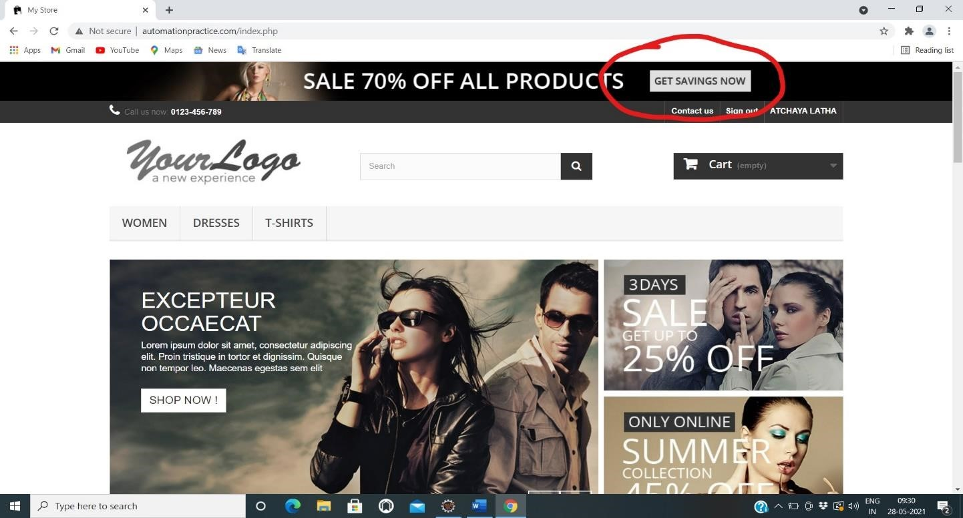

**TC03**

**To test the functionality**

**of “**

**Contact Us”**

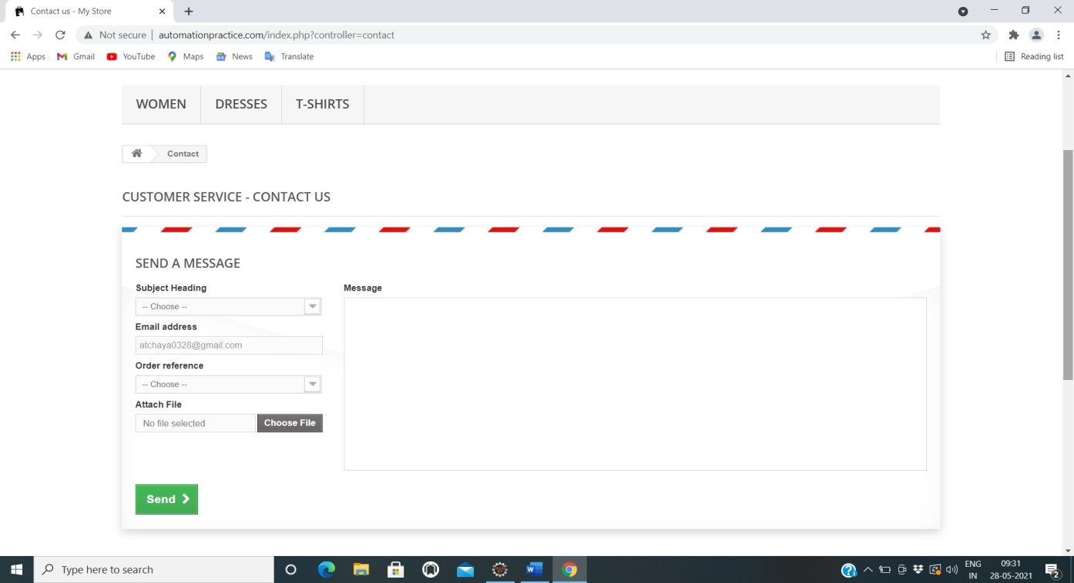

a1.selectByValue("1");

w.findElement(By.*id*("email")).sendKeys("atchaya17@gmail.com");

w.findElement(By.*id*("id_order")).sendKeys("AT0328");

whaya.pdf".findElement(By.); *id*("fileUpload")).sendKeys("C:/Users/atcha/Downloads/Atc

w.findElement(By.*id*("message")).sendKeys("Defective Product Received");

w.findElement(By.*id*("submitMessage")).click();

## TC04 To test the functionality of “Sign-In”

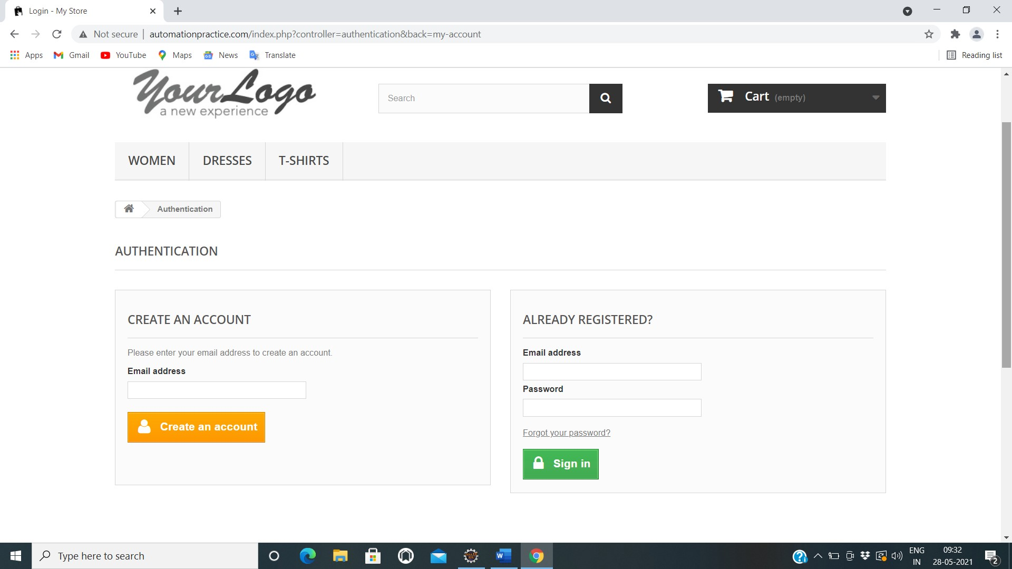

|  |
| --- |
| w.findElement(By.*xpath*("//a[contains(text(),'Sign in')]")).click();  w.findElement(By.*id*("email_create")).sendKeys("atchaya17@gmail.com");  w.findElement(By.*name*("SubmitCreate")).click(); |

## TC05 To test the functionality of “Create an Account”

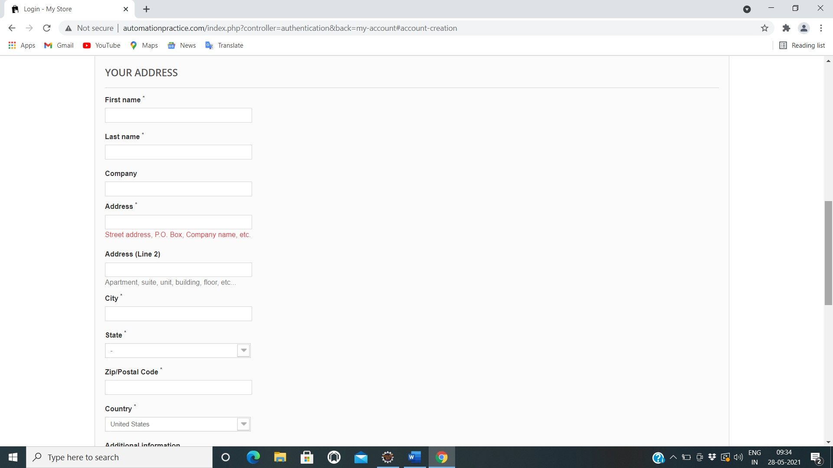

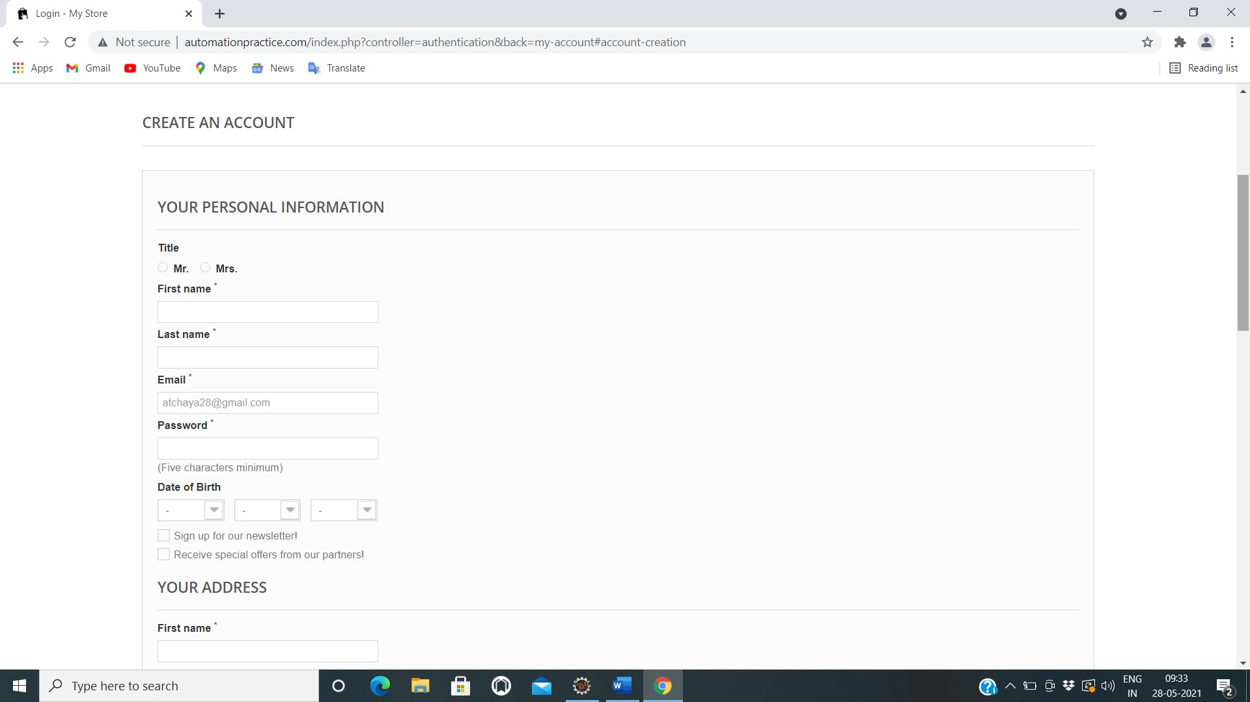

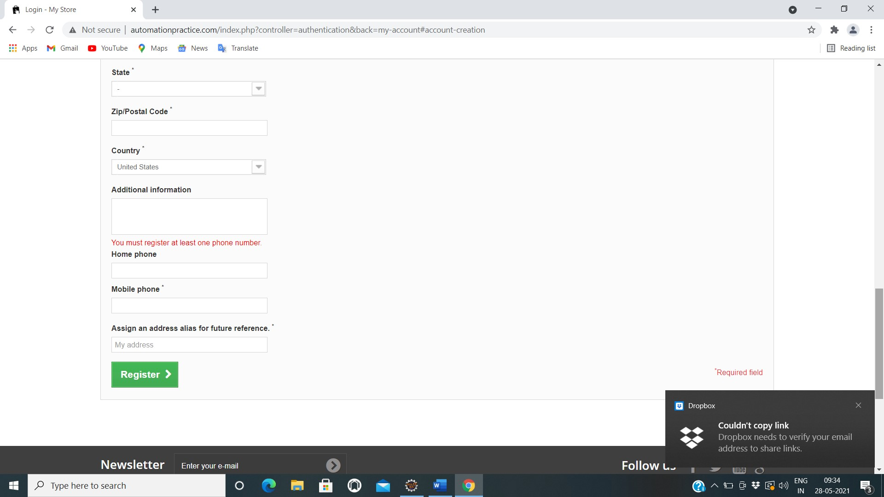

|  |
| --- |
| Thread.*sleep*(5000);  w.findElement(By.*id*("id_gender2")).click();  w.findElement(By.*id*("customer_firstname")).sendKeys("ATCHAYA");  w.findElement(By.*id*("customer_lastname")).sendKeys("LATHA")  w.findElement(By.*id*("passwd")).sendKeys("Atchu@08") Select a3=**new** Select(w.findElement(By.*id*("days"))); a3.selectByValue("28");  Select a4=**new** Select(w.findElement(By.*id*("months"))); a4.selectByValue("10");  Select a5=**new** Select(w.findElement(By.*id*("years")));  a5.selectByValue("1997");  w.findElement(By.*id*("newsletter")).click();  w.findElement(By.*id*("optin")).click();  w.findElement(By.*id*("firstname")).sendKeys("Atchaya");  w.findElement(By.*id*("lastname")).sendKeys("Latha");  w.findElement(By.*id*("company")).sendKeys("Capgemini");  w.findElement(By.*id*("address1")).sendKeys("xyz");  w.findElement(By.*id*("address2")).sendKeys("abc");  w.findElement(By.*id*("city")).sendKeys("kumbakonam"); Select a6=**new** Select(w.findElement(By.*id*("id_state"))); a6.selectByValue("14");  w.findElement(By.*id*("postcode")).sendKeys("00000"); Select a7=**new** Select(w.findElement(By.*id*("id_country"))); a7.selectByValue("21");  w.findElement(By.*id*("other")).sendKeys("Nill"); |

w.findElement(By.*id*("phone")).sendKeys("8220190545"); w.findElement(By.*id*("phone_mobile")).sendKeys("8248934920"); w.findElement(By.*id*("alias")).sendKeys("abcd");

w.findElement(By.*id*("submitAccount")).click();

w.navigate().back();

**TC06**

**To**

**T**

**est the functionality**

**of “Already Registered”**



w.findElement(By.*id*("email")).sendKeys("atchaya17@gmail.com");

w.findElement(By.*id*("passwd")).sendKeys("Atchu@0328"); w .findElement(By.*id*("SubmitLogin")).click();



## TCO7 To test the functionality of “My Account”

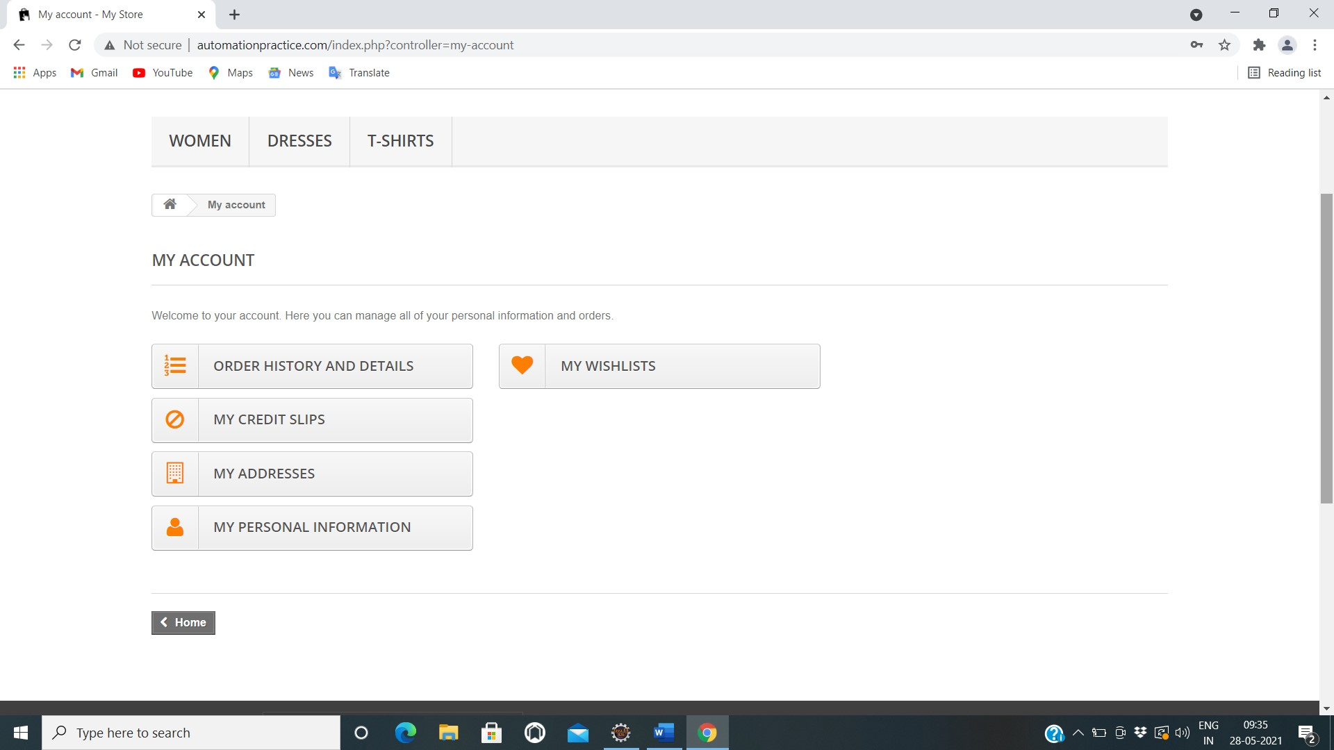

Thread.*sleep*(5000);

w.findElement(By.*xpath*("//span[contains(text(),'Order history and details')]")).click();

w.findElement(By.*xpath*("//body[1]/div[1]/div[2]/div[1]/div[3]/div[1]/ul[

1]/li[1]/a[1]/span[1]")).click();

w.findElement(By.*xpath*("//span[contains(text(),'My credit slips')]")).click();

w.findElement(By.*xpath*("//body[1]/div[1]/div[2]/div[1]/div[3]/div[1]/ul[

1]/li[1]/a[1]/span[1]")).click();

w.findElement(By.*xpath*("//span[contains(text(),'My addresses')]")).click();

w.findElement(By.*xpath*("//body[1]/div[1]/div[2]/div[1]/div[3]/div[1]/ul[

1]/li[1]/a[1]/span[1]")).click();

w.findElement(By.*xpath*("//span[contains(text(),'My personal information')]")).click();

w.findElement(By.*xpath*("//body[1]/div[1]/div[2]/div[1]/div[3]/div[1]/ul[

1]/li[1]/a[1]/span[1]")).click();

w.findElement(By.*xpath*("//span[contains(text(),'My wishlists')]")).click();

w.findElement(By.*id*("name")).sendKeys("Atchu");

w.findElement(By.*id*("submitWishlist")).click();

w.findElement(By.*xpath*("//body[1]/div[1]/div[2]/div[1]/div[3]/div[1]/ul[ 1]/li[1]/a[1]/span[1]")).click();

w.findElement(By. *xpath*("//body/div[@id='page']/div[2]/div[1]/div[3]/div[1] /ul[1]/li[1]/a[1]")).click();

w.findElement(By.*xpath* ("//header/div[2]/div[1]/div[1]/nav[1]/div[2]/a[1]")

).click();

w.findElement(By.*xpath*("//body[1]/div[1]/div[2]/div[1]/div[3]/div[1]/ul[1]

/li[1]/a[1]/span[1]")).click();

w.close();

## TC08 To test the functionality of “T-shirt button”

|  |  |  |  |  |
| --- | --- | --- | --- | --- |
| |  |  | | --- | --- | | w.findElement(By.*xpath*("//header/div[3]/div[1]/div[1]/div[6]/ul[1]/li[ | | | 3]/a[1]")).click(); |  | |

**TC09**

**To test the functionality**

**of “All checkbox”**

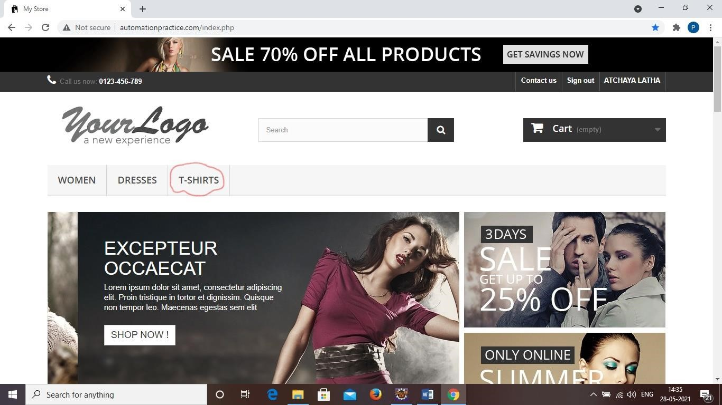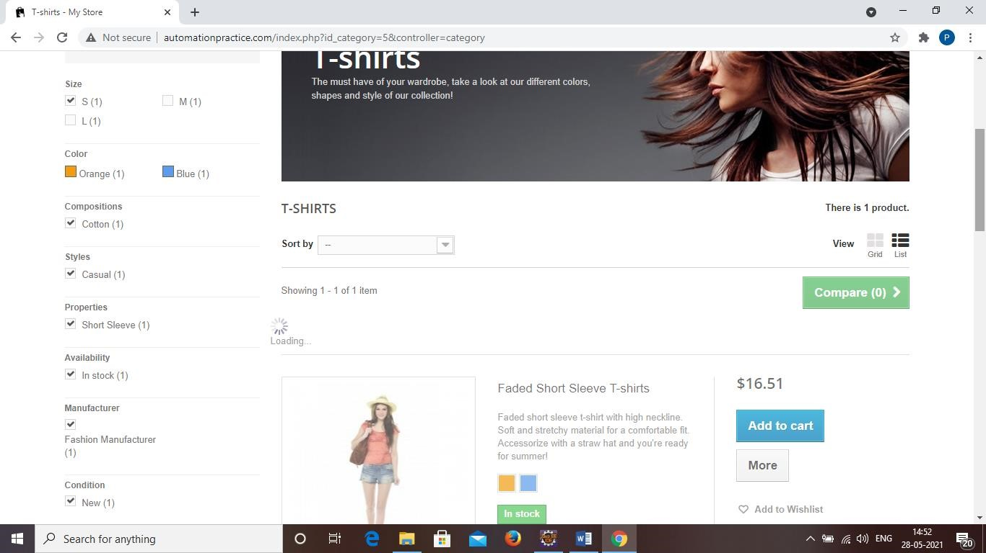

w.findElement(By.*id*("layered_id_attribute_group_1")).click();

w.findElement(By.*id*("layered_id_feature_5")).click();

w.findElement(By.*id*("layered_id_feature_11")).click();

w.findElement(By.*id*("layered_id_feature_17")).click();

w.findElement(By.*id*("layered_quantity_1")).click();

w.findElement(By.*id*("layered_manufacturer_1")).click();

w.findElement(By.*id*("layered_condition_new")).click();

**TC10**

**To test the functionality**

**of “Sort by**

**-**

**dropdown**

**”**

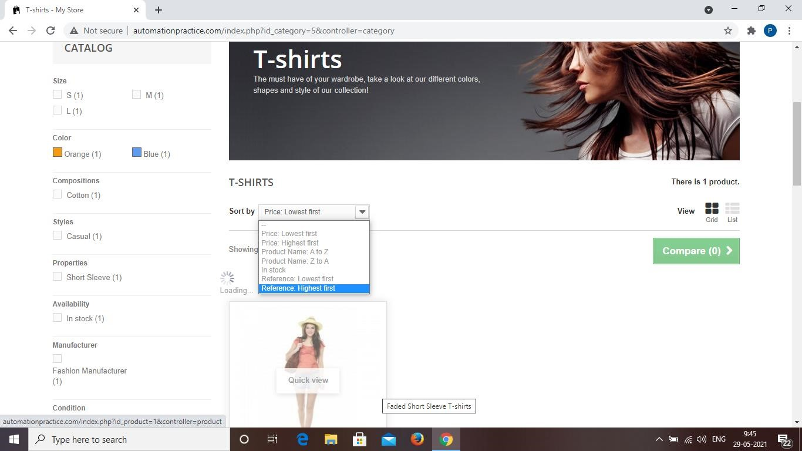

Select s=**new** Select (w.findElement(By.*id*("selectProductSort"))); s.selectByVisibleText("Price: Lowest first");

## TC11 To test the functionality of “List buttton”

|  |  |  |  |  |
| --- | --- | --- | --- | --- |
| |  |  | | --- | --- | | w.findElement(By.*xpath*("//body/div[@id='page']/div[2]/div[1]/div[3]/div[ | | | 2]/div[2]/div[1]/ul[1]/li[3]/a[1]/i[1]")).click(); |  | |

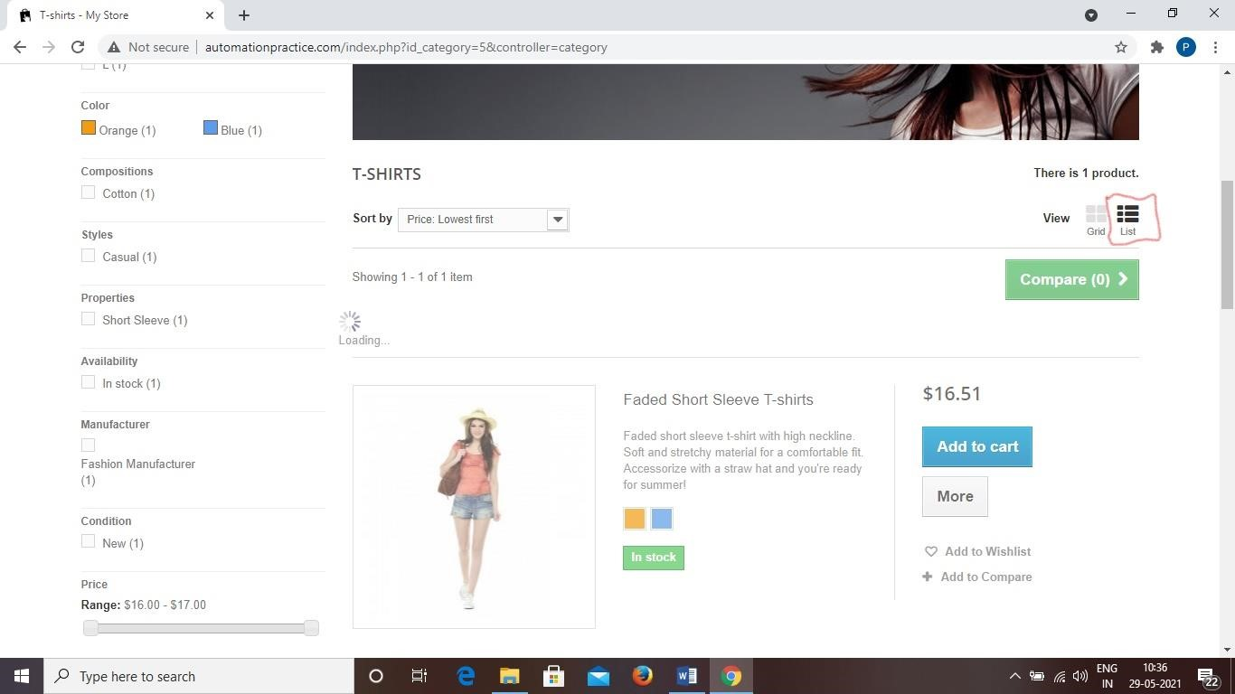

**TC12**

**To test the functionality**

**of “Quick view button”**

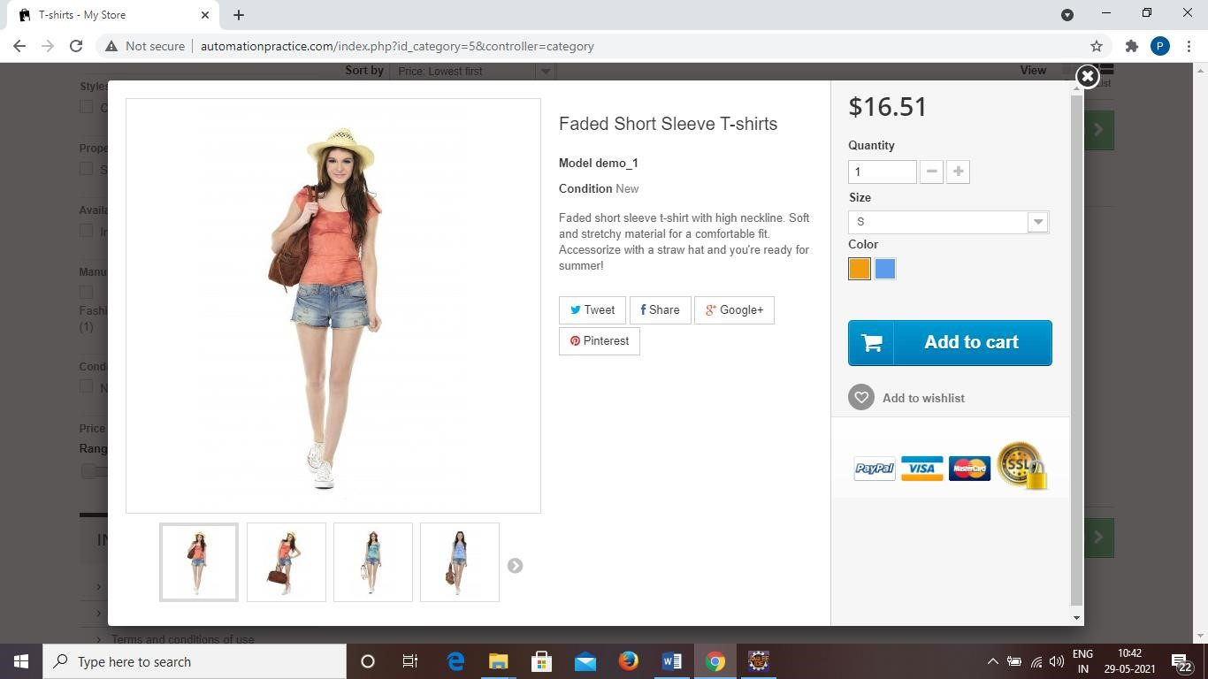

w.findElement(By.*xpath*("//span[contains(text(),'More')]")).click(); Thread.*sleep*(1000);

**TC13**

**To test the functionality**

**of “View larger button”**

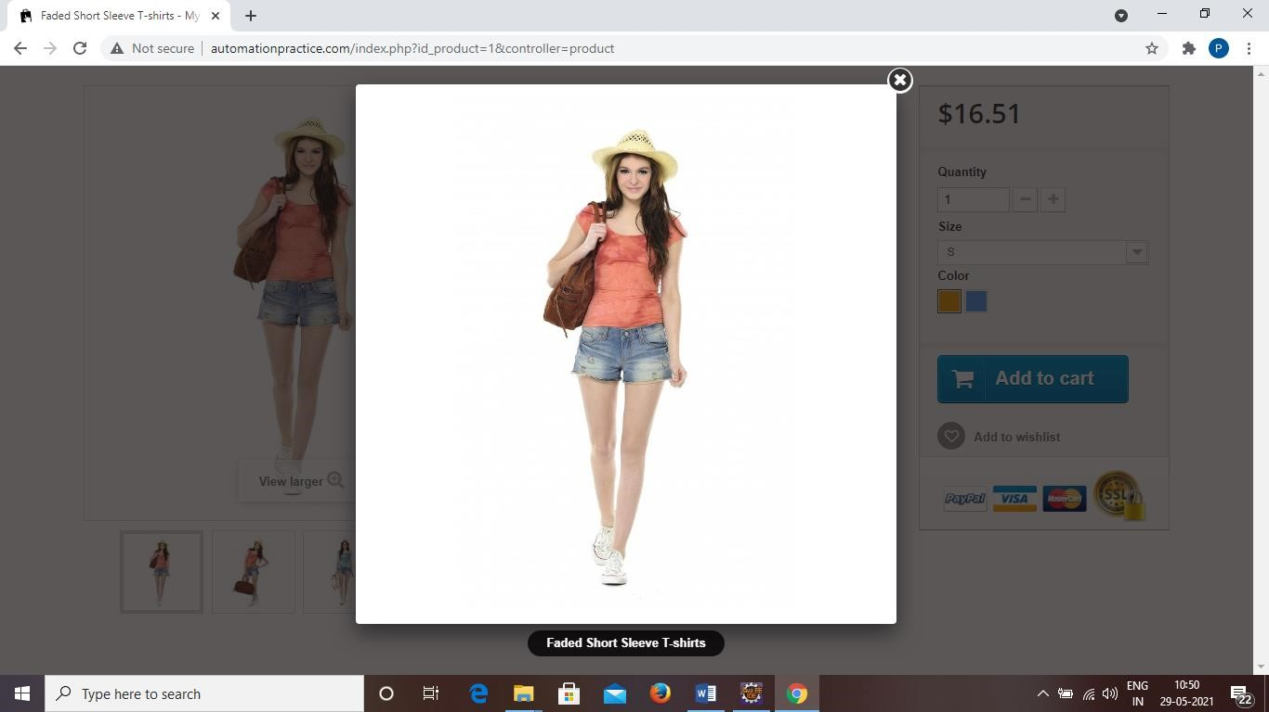

w.findElement(By.*id*("thumb_1")).click();

Thread.*sleep*(2000);

w.findElement(By.*xpath*("/html[1]/body[1]/div[2]/div[1]/div[1]/a[1]")).

click();

w.findElement(By.*id*("thumb_2")).click();

Thread.*sleep*(2000);

w.findElement(By.*xpath*("/html[1]/body[1]/div[2]/div[1]/div[1]/a[1]")).

click();

w.findElement(By.*id*("thumb_3")).click();

Thread.*sleep*(2000);

w.findElement(By.*xpath*("/html[1]/body[1]/div[2]/div[1]/div[1]/a[1]")).

click();

w.findElement(By.*id*("thumb_4")).click();

Thread.*sleep*(2000);

w.findElement(By.*xpath*("/html[1]/body[1]/div[2]/div[1]/div[1]/a[1]")). click();

Thread.*sleep*(1000);

## TC14 To test the functionality of “Add to cart button”

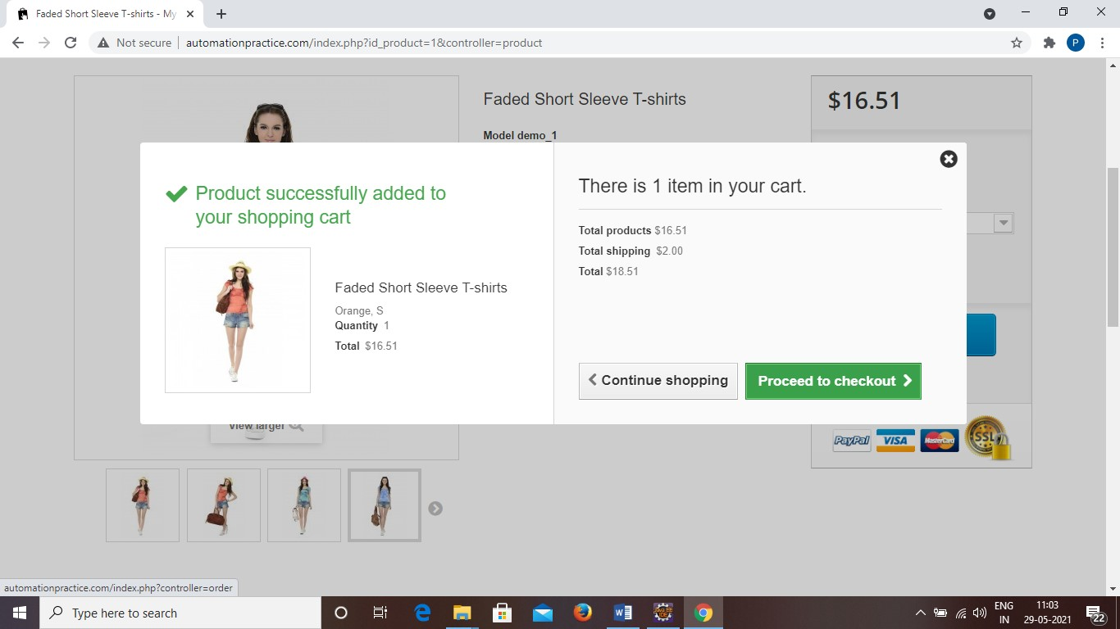

w.findElement(By.*xpath*("//span[contains(text(),'Add to cart')]"))

.click();

Thread.*sleep*(3000);

w.navigate().back();

## TC15 To test the functionality of “Cart”

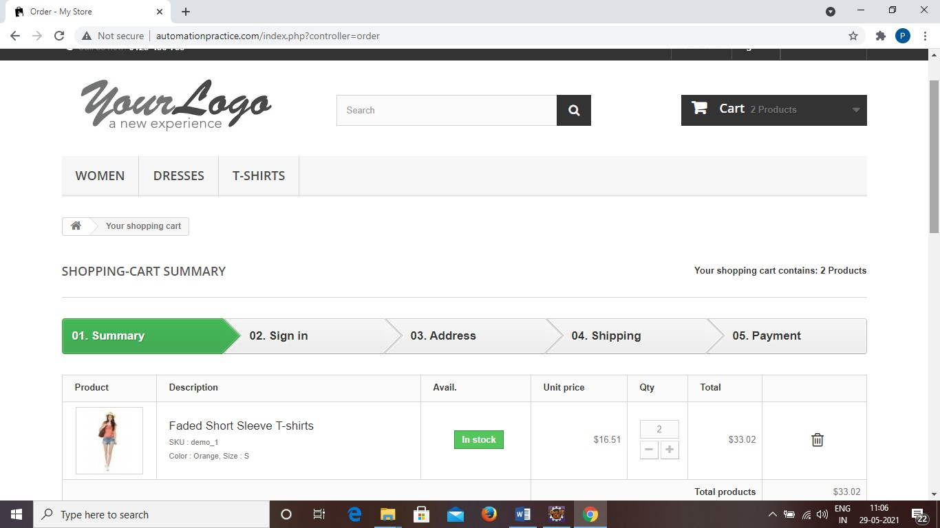

w.findElement(By.*xpath*("//header/div[3]/div[1]/div[1]/div[3]/div[1]/a[1]")) .click()

Thread.*sleep*(1000);

## TC16 To test the functionality of “Proceed to checkout button”

|  |  |  |  |  |
| --- | --- | --- | --- | --- |
| |  |  | | --- | --- | | w.findElement(By.*xpath*("//body[1]/div[1]/div[2]/div[1]/div[3]/div[1]/p | | | [2]/a[1]/span[1]")).click(); |  | |

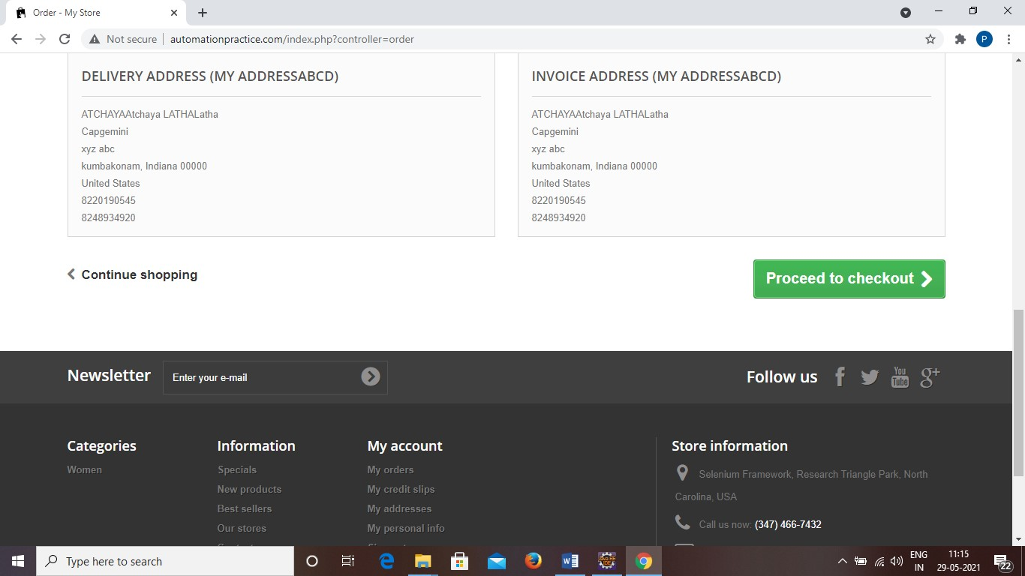

## TC17 To test the functionality of “Already Registered”

w.findElement(By.*id*("email")).sendKeys("atchaya17@gmail.com");

w.findElement(By.*id*("passwd")).sendKeys("Atchu@0328");

w.findElement(By.*id*("SubmitLogin")).click();

**TC18**

**To test the functionality**

**of “Address”**

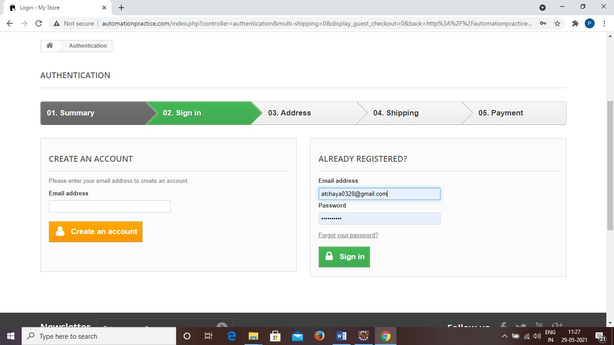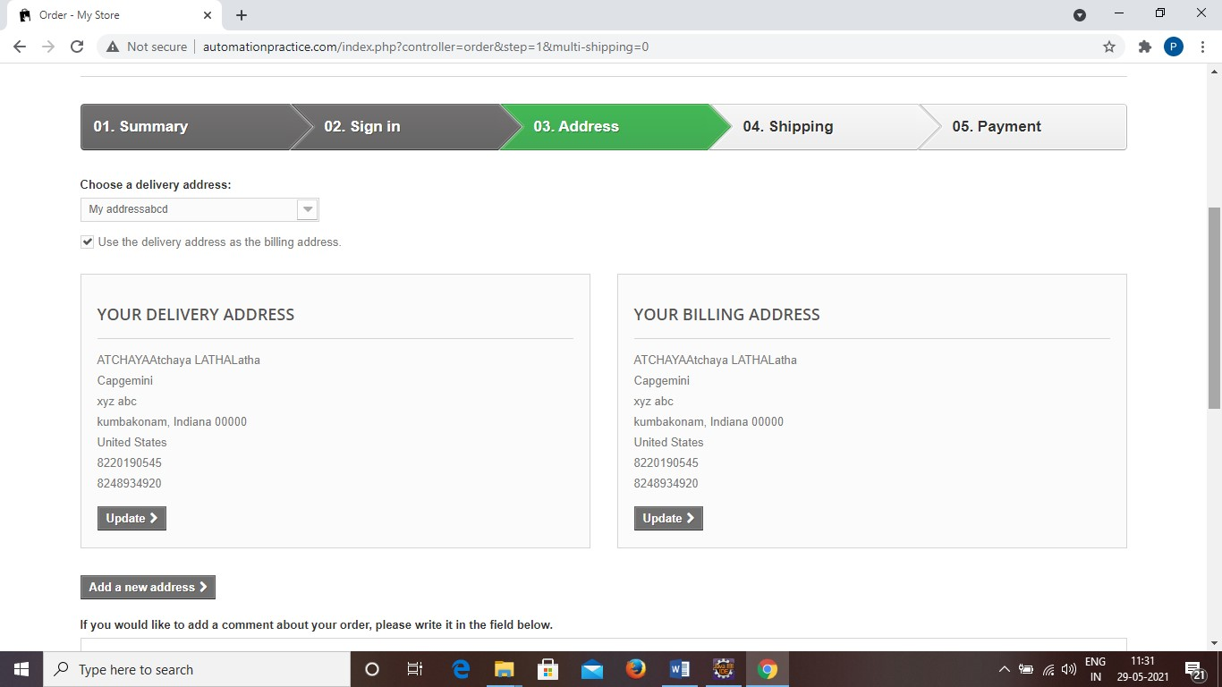

w.findElement(By.*name*("processAddress")).click();

**TC19**

**To test the functionality**

**of “Shipping”**

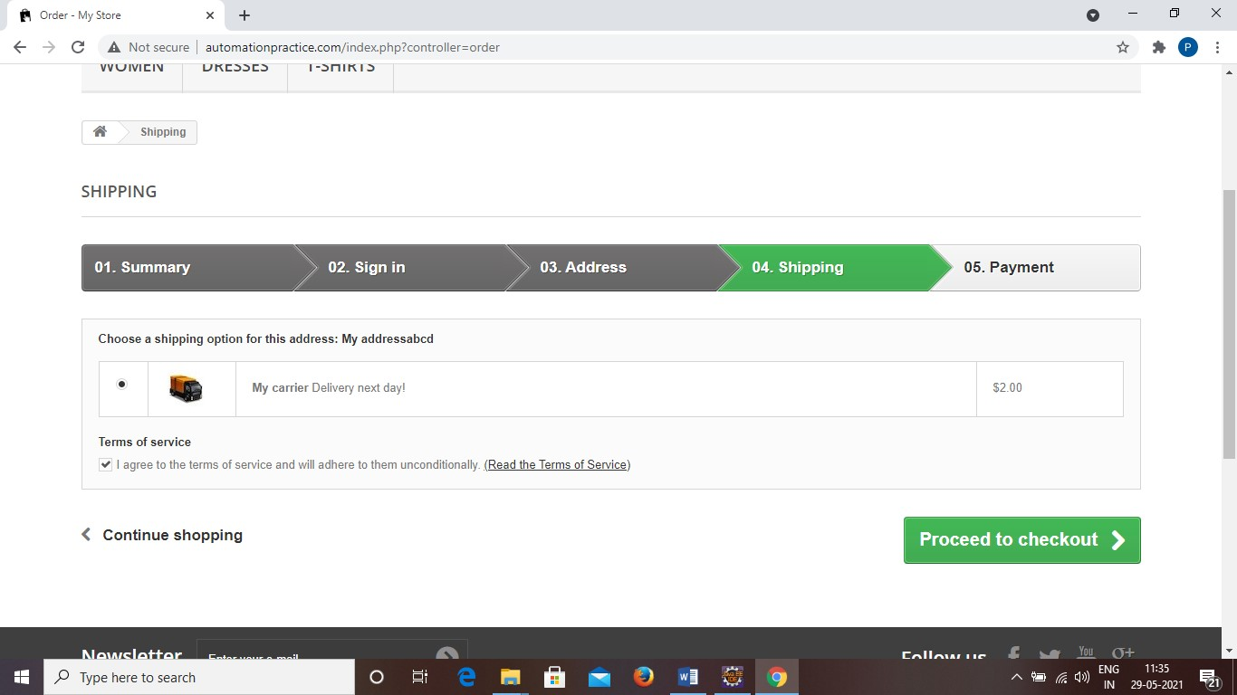

w.findElement(By.*id*("cgv")).click();

w.findElement(By.*name*("processCarrier")).click();

**TC20**

**To test the functionality**

**of “Payment”**

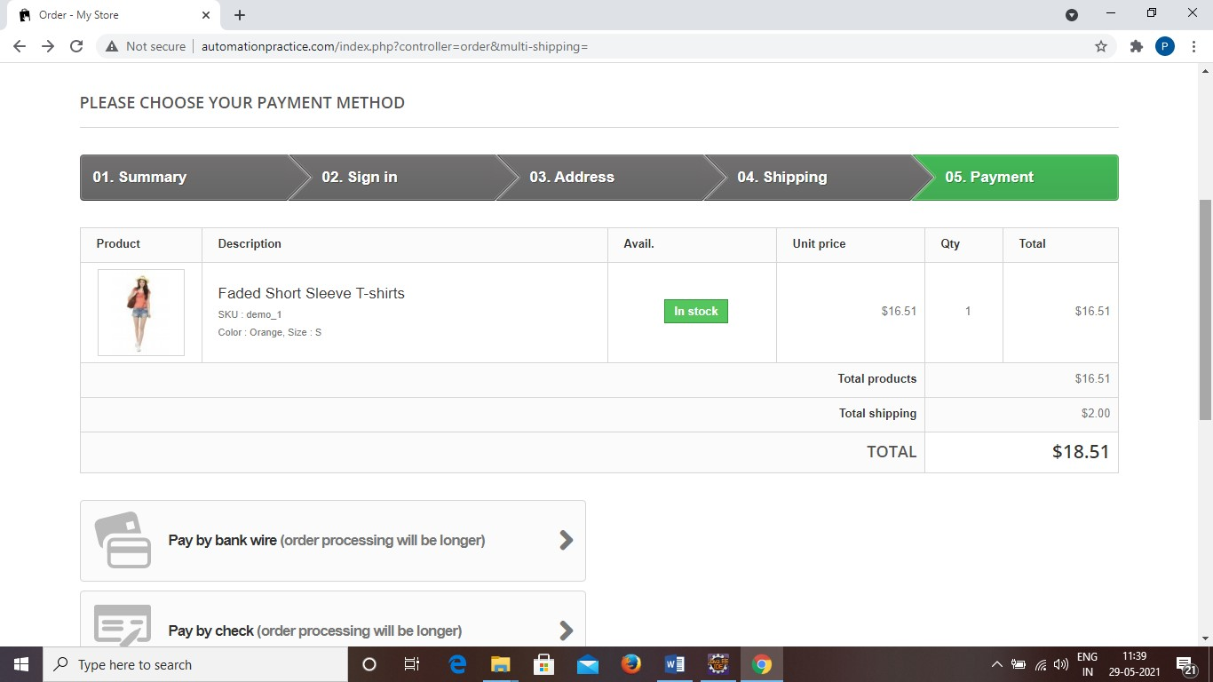

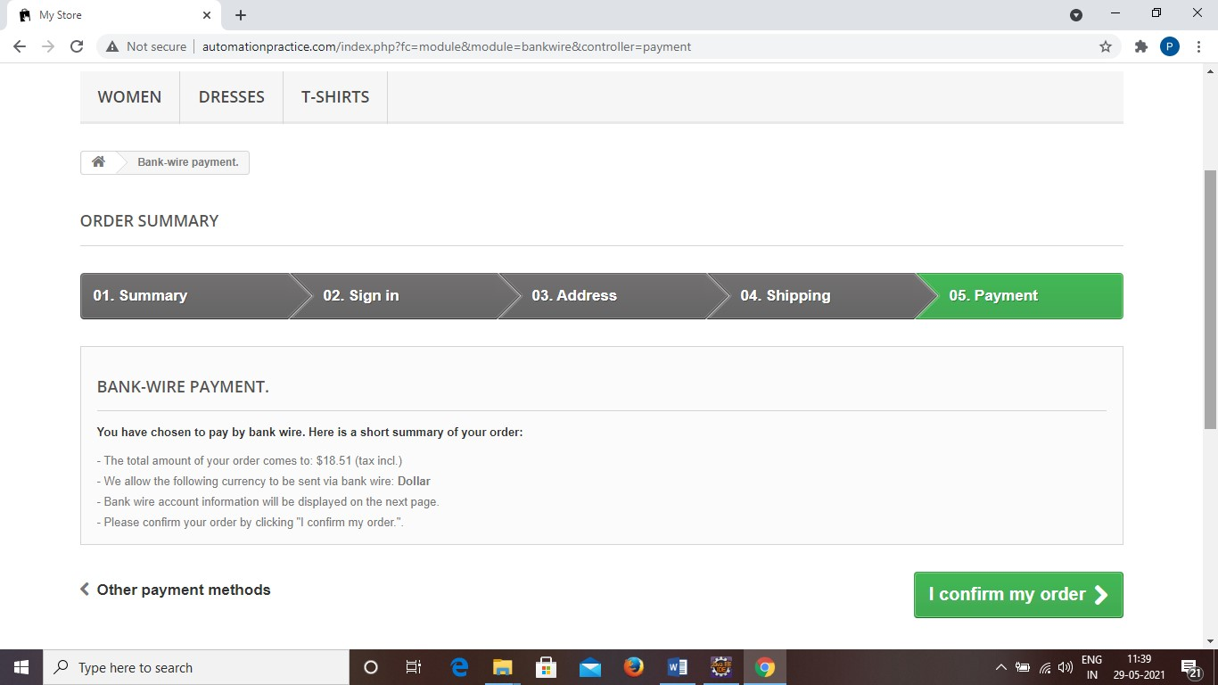

w.findElement(By.*xpath*("//body[1]/div[1]/div[2]/div[1]/div[3]/div[1]/div[1 ]/div[3]/div[1]/div[1]/p[1]/a[1]/span[1]")).click();

w.findElement(By.*xpath*("//body[1]/div[1]/div[2]/div[1]/div[3]/div[1]/form[

1]/p[1]/button[1]/span[1]")).click();

## TC21 To Take the screenshot of “Order Confirmation”

TakesScreenshot t = (TakesScreenshot) w;

File src = t.getScreenshotAs(OutputType.***FILE***);

Files.*copy*(src, **new** File("F:\\Screenshot\\P345.png"));

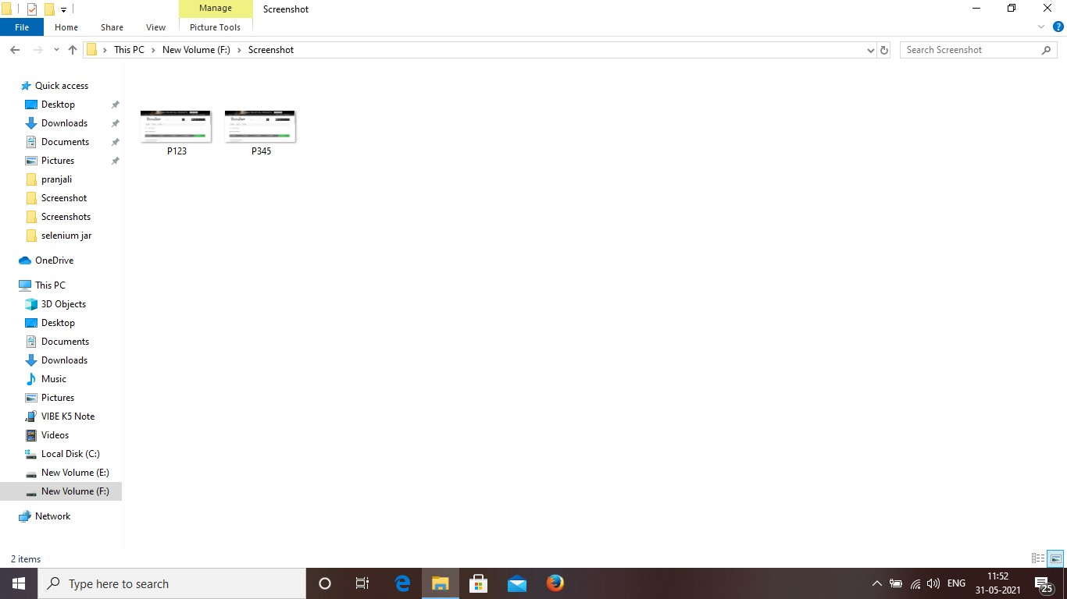

**TC22**

**To test the functionality**

**of “Back to orders”**

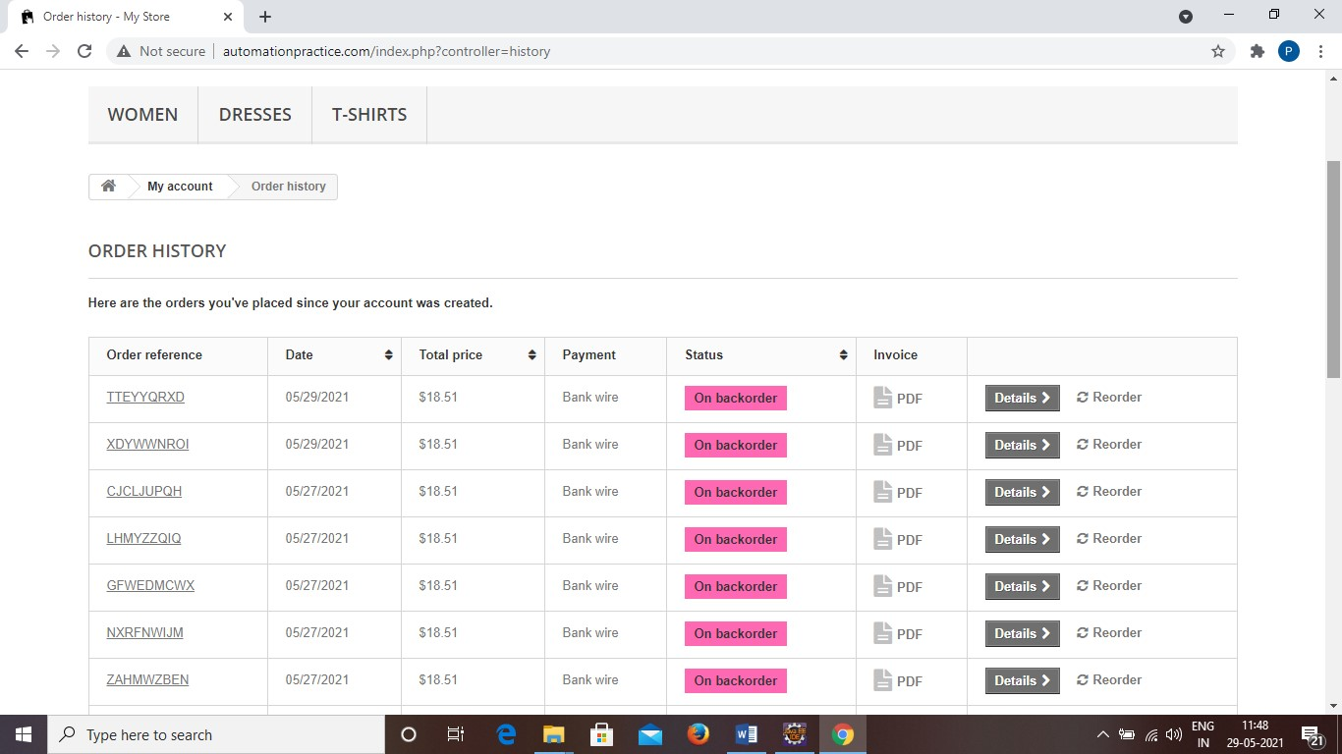

|  |  |  |  |  |
| --- | --- | --- | --- | --- |
| |  |  | | --- | --- | | w.findElement(By.*xpath*("//body/div[@id='page']/div[2]/div[1]/div[3]/d | | | iv[1]/p[1]/a[1]")).click(); |  | |

**TC23**

**To test the functionality**

**of “Back to Home”**

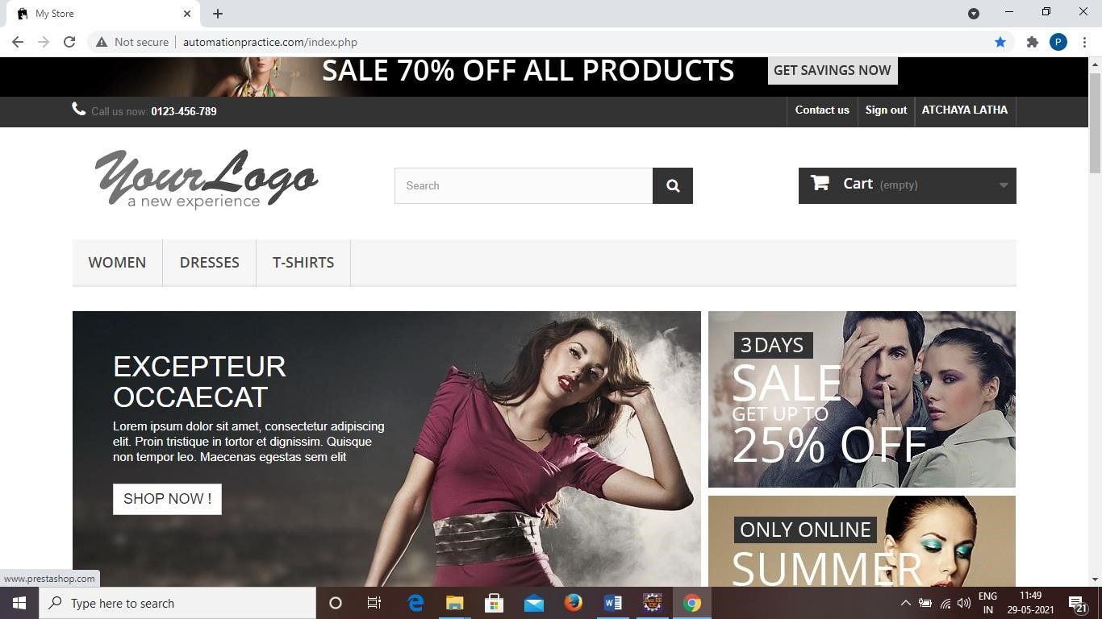

w.findElement(By.*xpath*("/html[1]/body[1]/div[1]/div[2]/div[1]/div[3]/div[1] /ul[1]/li[2]/a[1]/span[1]")).click()

w.close();

**T**

**C24 T**

**o test the functionality**

**of “**

**Woman Tab**

**”**

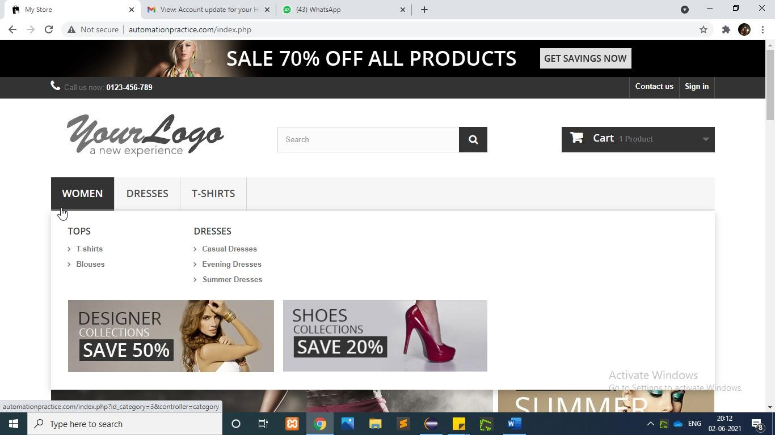

Actions actions=**new** Actions(w);

w.manage().timeouts().implicitlyWait(2000, TimeUnit.***MILLISECONDS***);

WebElement womenTab=w.findElement(By.*linkText*("WOMEN"));

WebElementTshirtTab=w.findElement(By.*xpath*("//div[@id='block_top_menu']/ul/ li[1]/ul/li[1]/ul//a[@title='T-shirts']"));

actions.moveToElement(womenTab).moveToElement(TshirtTab).click().perform();

## TC25 To test the functionality of “Size Option”

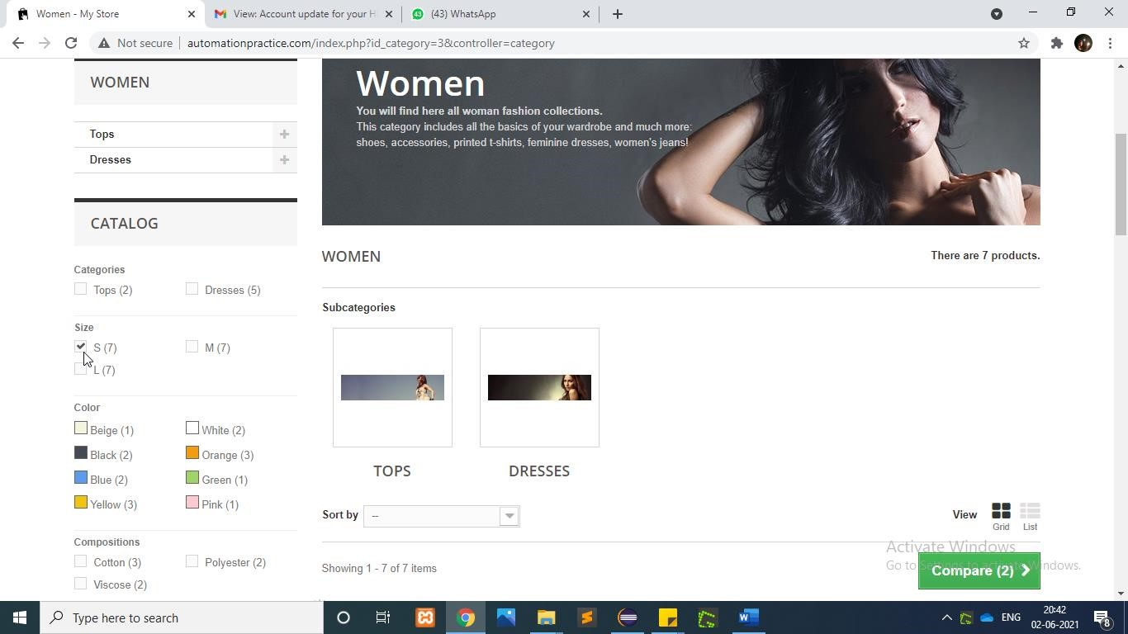

|  |
| --- |
| WebElement size=w.findElement(By.*xpath*("/html[1]/body[1]/div[1]/div[2]/ div[1]/div[3]/div[1]/div[1]/div[1]/form[1]/div[1]/div[1]/ul[1]/li[1]/div[1]  /span[1]/input[1]")); size.click(); |

**T**

**C26**

**To test the functionality**

**of “**

**Composition**

**Option”**

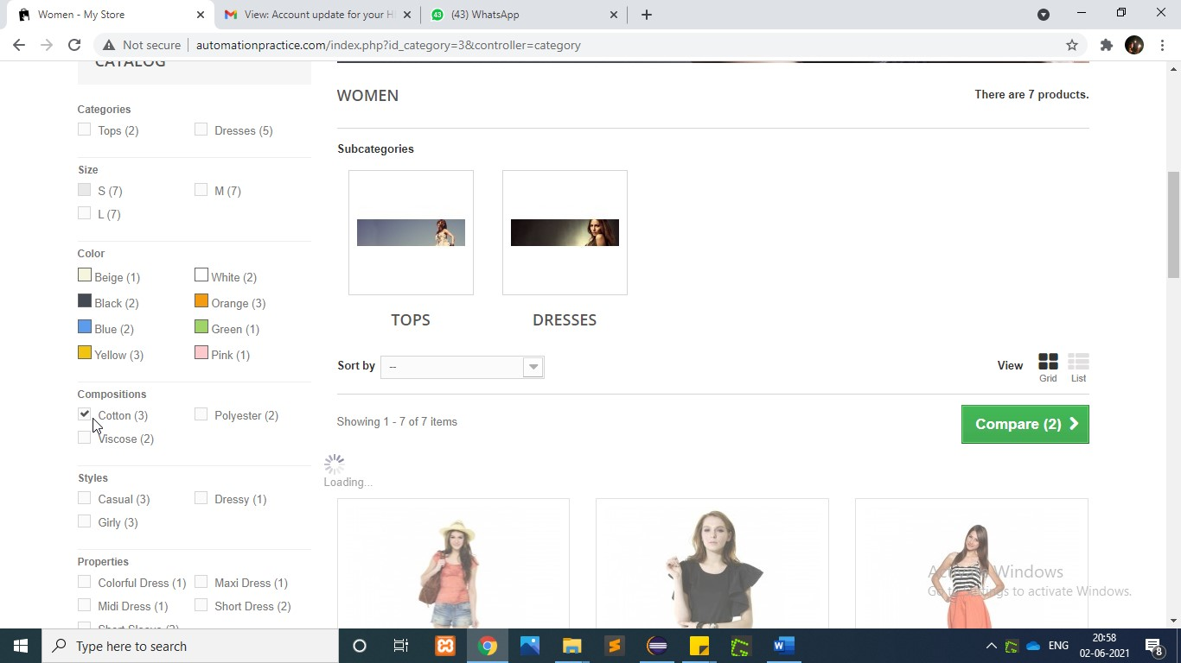

|  |
| --- |
| WebElement Compositions=w.findElement(By.*xpath*("/html[1]/body[1]/div[1]    /div[2]/div[1]/div[3]/div[1]/div[1]/div[1]/form[1]/div[1]/div[3]/ul[1]/li[1  ]/div[1]/span[1]/input[1]")); Compositions.click(); |

**T**

**C27**

**To test the functionality**

**of “Style**

**Option”**

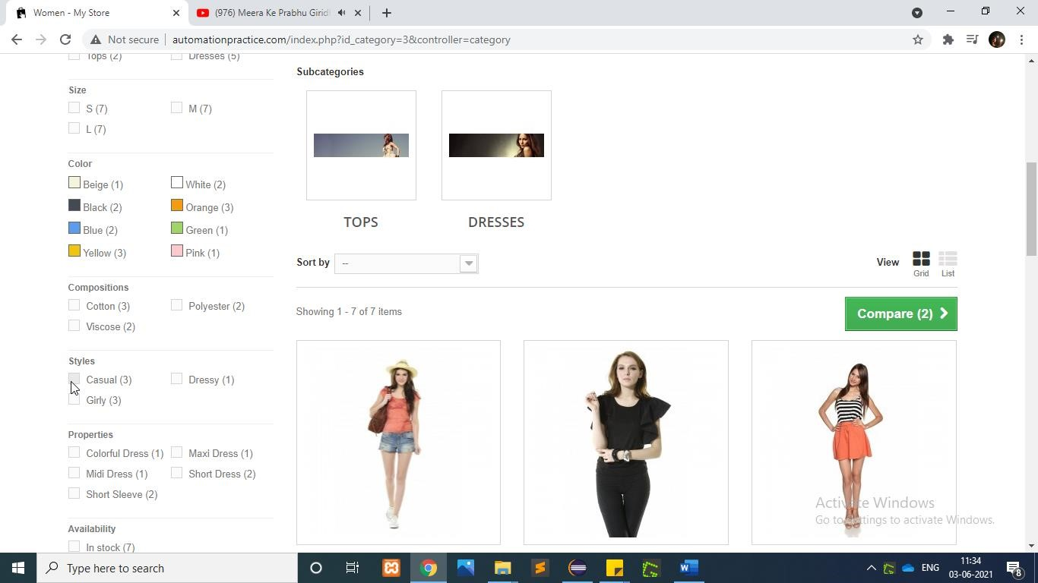

|  |
| --- |
| WebElement style=w.findElement(By.*xpath*("/html[1]/body[1]/div[1]/ div[2]/div[1]/div[3]/div[1]/div[1]/div[1]/form[1]/div[1]/div[3]/ul[1]/li[1]  /div[1]/span[1]/input[1]")); style.click(); |

## TC28 To test the functionality of “Search Box”

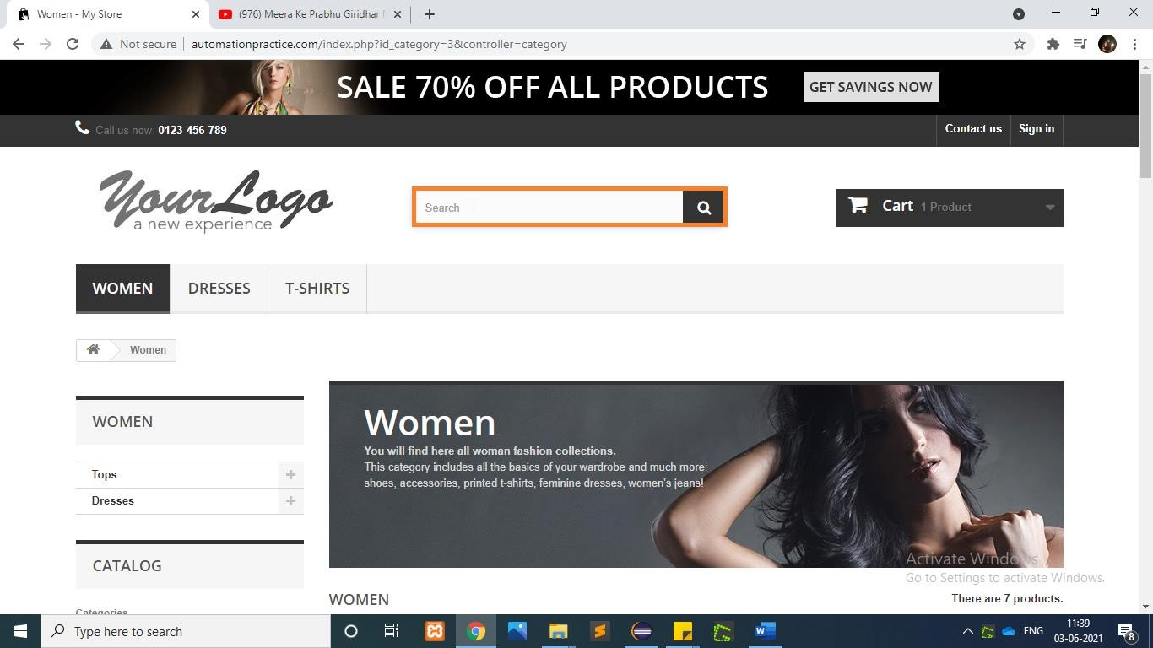

|  |
| --- |
| String ProductName=w.findElement(By.*xpath*("/html[1]/body[1]/div[1]/div[2]    /div[1]/div[3]/div[2]/ul[1]/li[1]/div[1]/div[2]/h5[1]/a[1]")).getText(); System.***out***.println(ProductName);    w.findElement(By.*id*("search_query_top")).sendKeys(ProductName);  w.findElement(By.*name*("submit_search")).click(); |

## TC29 To test the functionality of “Sort Using Selecting Category”

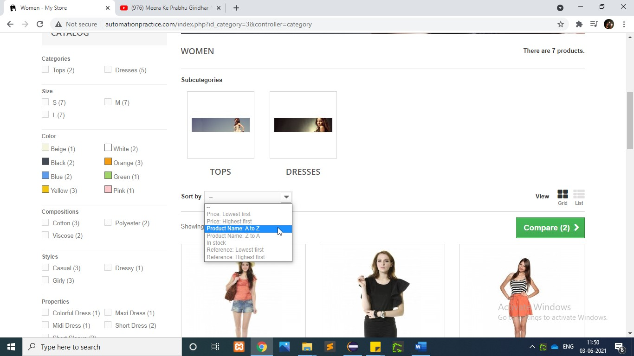

WebElement productCategory=w.findElement(By.*id*("selectProductSort"));

Select pSelectC=**new** Select(productCategory); pSelectC.selectByVisibleText("Product Name: A to Z");

w.navigate().back();

**T**

**C30**

**To test the functionality**

**of**

**“Sign In**

**”**

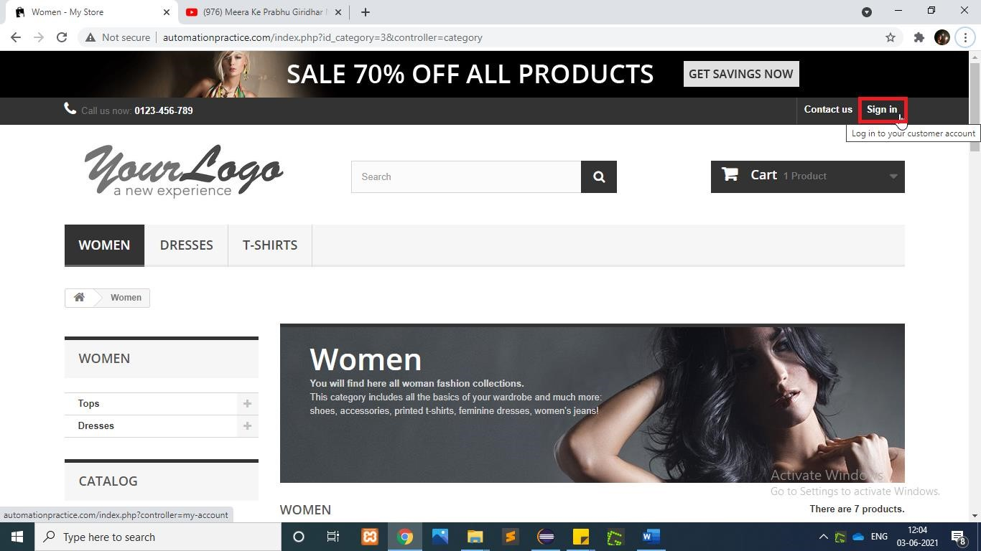

w.findElement(By.*linkText*("Sign in")).click();

**T**

**C31**

**To test the functionality**

**of “**

**Login**

**Button**

**”**

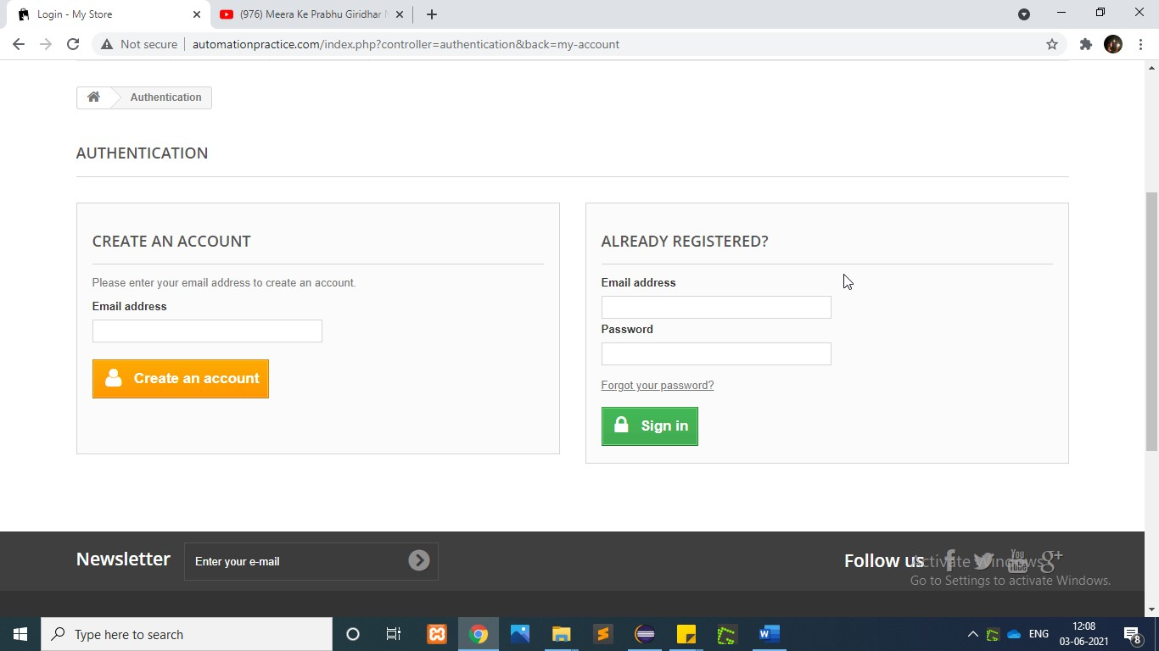

|  |
| --- |
| w.findElement(By.*id*("email")).sendKeys("vsoft1120@test.com");  w.findElement(By.*id*("passwd")).sendKeys("vosft1212");    w.findElement(By.*id*("SubmitLogin")).click(); |

## TC32 To test the functionality of “More Button”

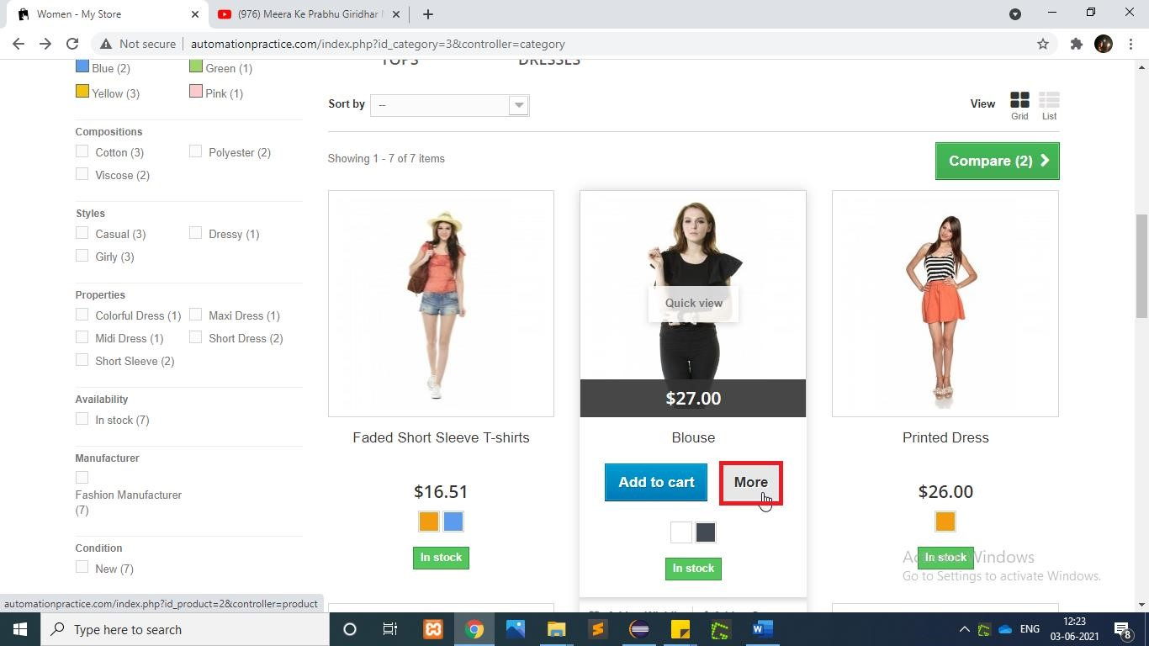

w.findElement(By.*xpath*("/html[1]/body[1]/div[1]/div[1]/header[1]/div[3]/div

[1]/div[1]/div[6]/ul[1]/li[1]/a[1]")).click();

WebElement SecondImg=w.findElement(By.*xpath*("/html/body/div[1]/div[2] /div/div[3]/div[2]/ul/li[2]/div/div[1]/div/a[1]/img"));

WebElement MoreButton=w.findElement(By.*xpath*("/html/body[1]/div[1]/div[2]

/div[1]/div[3]/div[2]/ul/li[2]/div[1]/div[2]/div[2]/a[2]"));

Actions actions1=**new** Actions(w); actions1.moveToElement(SecondImg).moveToElement(MoreButton).click().perform

();

## TC33 To test the functionality of “Increase The Quantity”

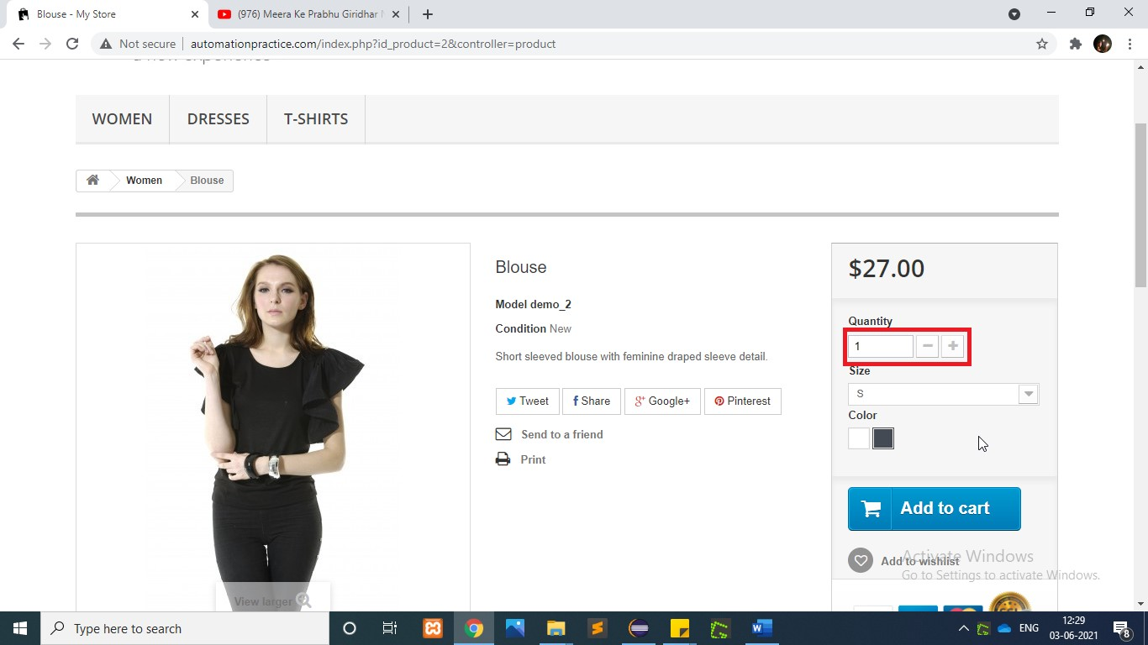

w.findElement(By.*id*("quantity_wanted")).clear();

w.findElement(By.*id*("quantity_wanted")).sendKeys("2");

**T**

**C34**

**To test the functionality**

**of “Select The Size”**

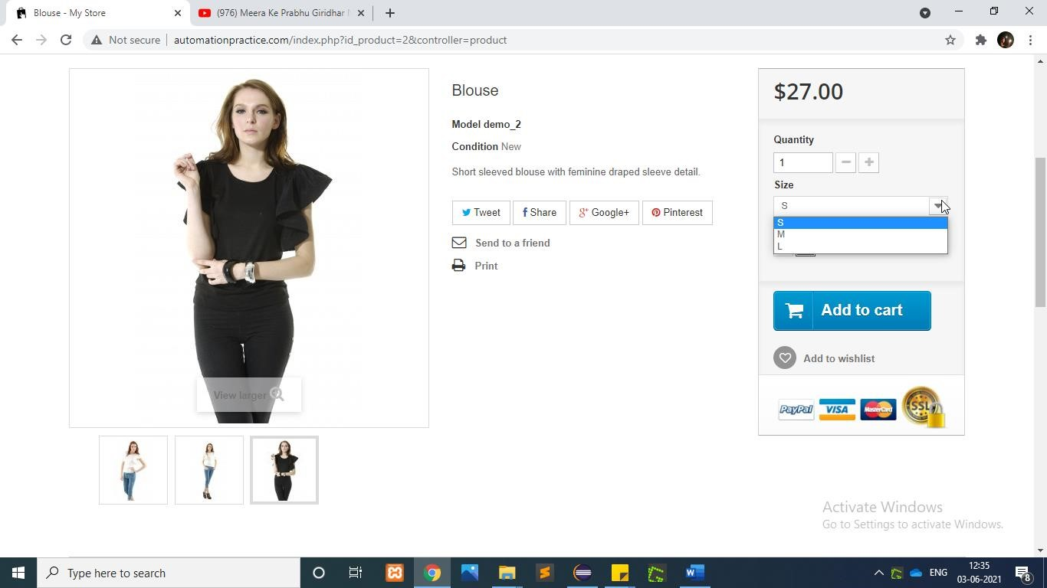

WebElement Sizedrpdwn=w.findElement(By.*xpath*("//*[@id='group_1']"));

Select orderSelect=**new** Select(Sizedrpdwn); orderSelect.selectByVisibleText("M");

**T**

**C35**

**To test the functionality**

**of “Select The**

**Color**

**”**

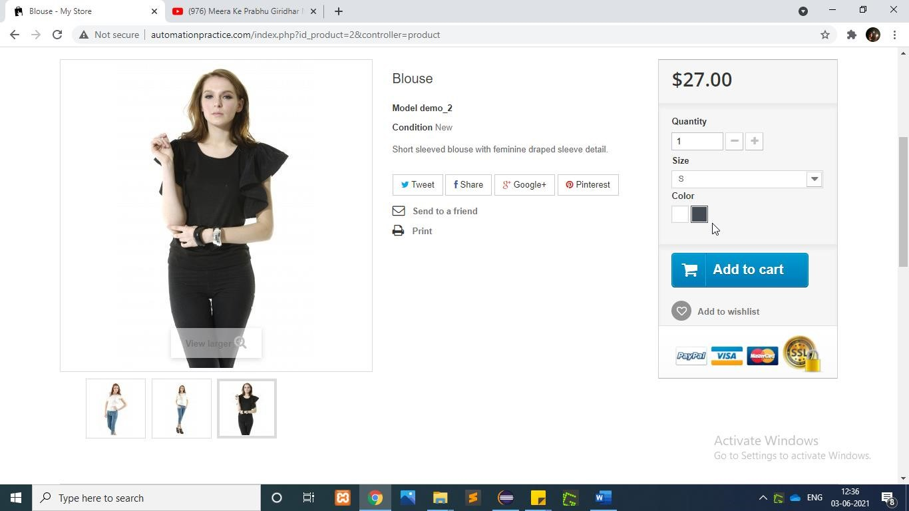

w.findElement(By.*id*("color_11")).click();

## TC36 To test the functionality of “Add To Cart(Woman)”

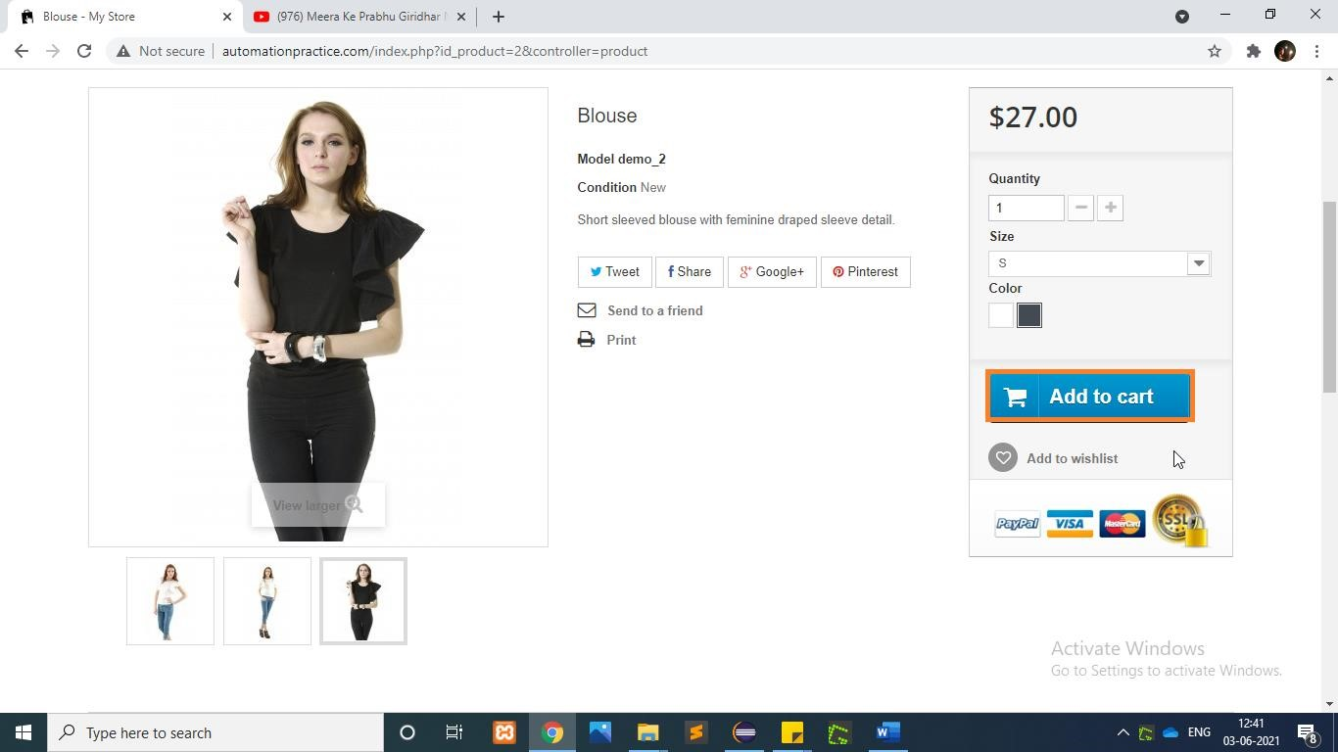

w.findElement(By.*xpath*("//p[@id='add_to_cart']//span[.='Add to cart']" )).click();

**T**

**C37**

**To test the functionality**

**of**

**“**

**Proceed to Checkout**

**”**

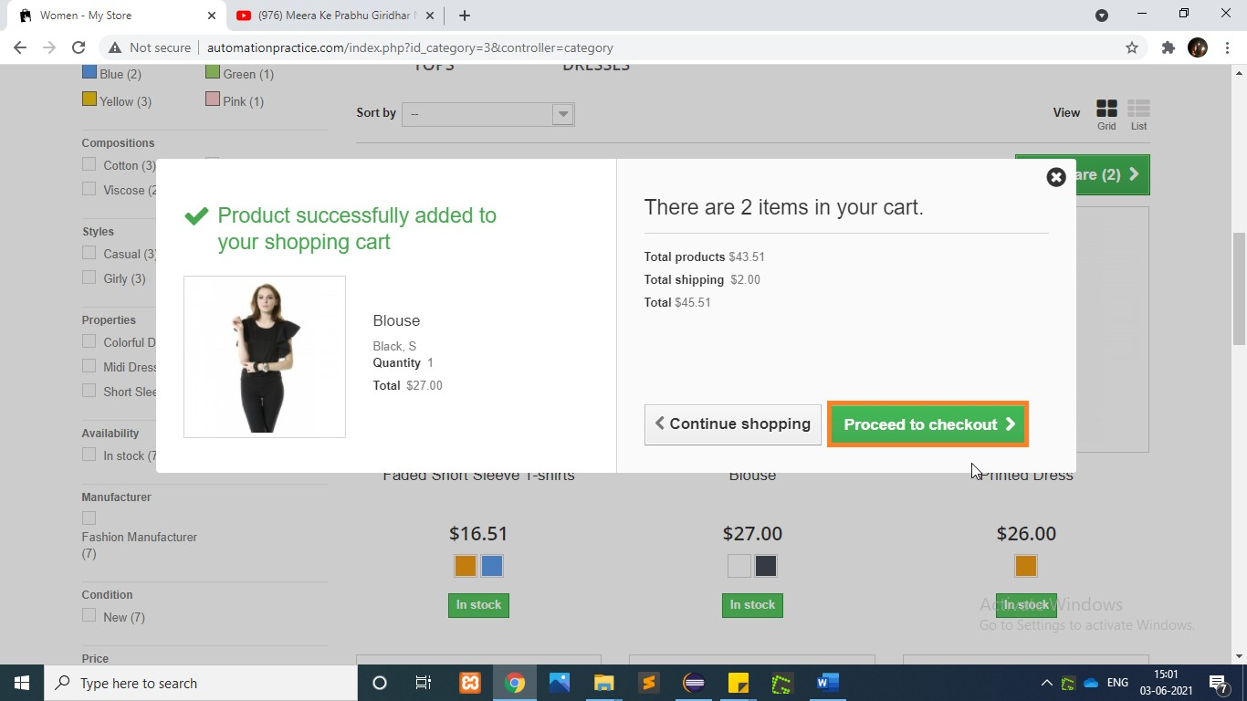

|  |  |  |  |  |
| --- | --- | --- | --- | --- |
| |  |  | | --- | --- | | .findElement(By.*xpath*("/html[1]/body[1]/div[1]/div[1]/header[1]/div[3]/div | | | [1]/div[1]/div[4]/div[1]/div[2]/div[4]/a[1]/span[1]")).click(); |  |   w |

**T**

**C38**

**To test the functionality**

**of “**

**Summery**

**”**

**T**

**C39**

**To test the functionality**

**of**

**“Checkout to proceed**

**”**

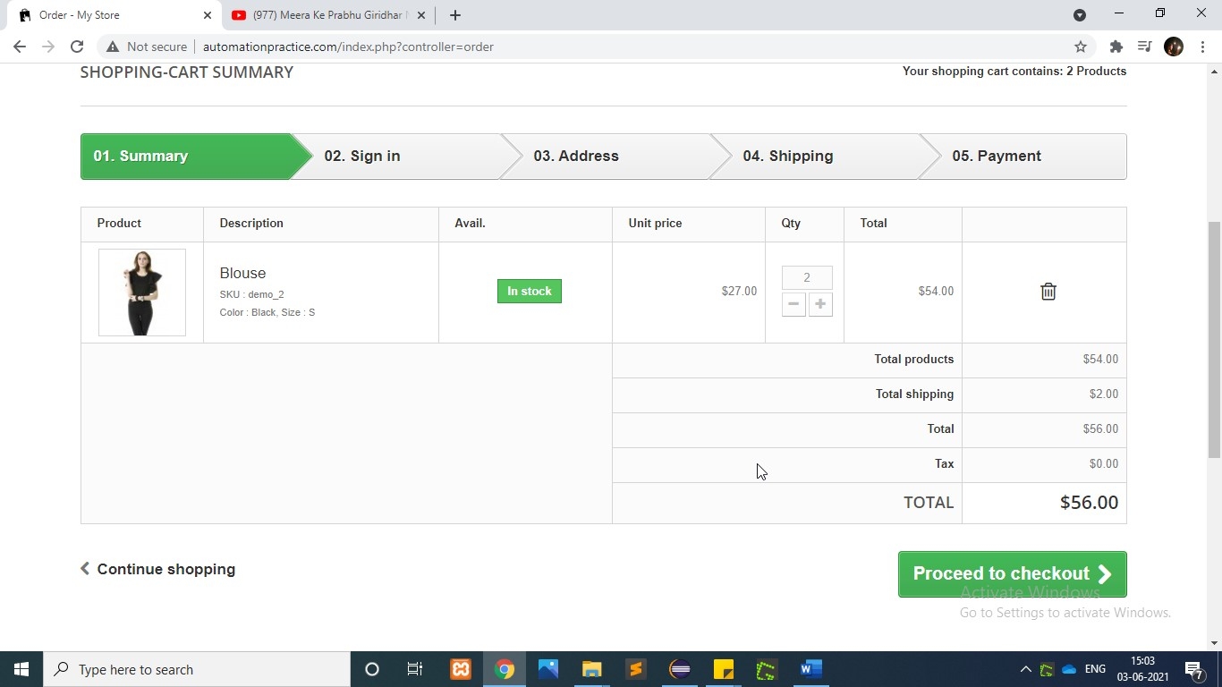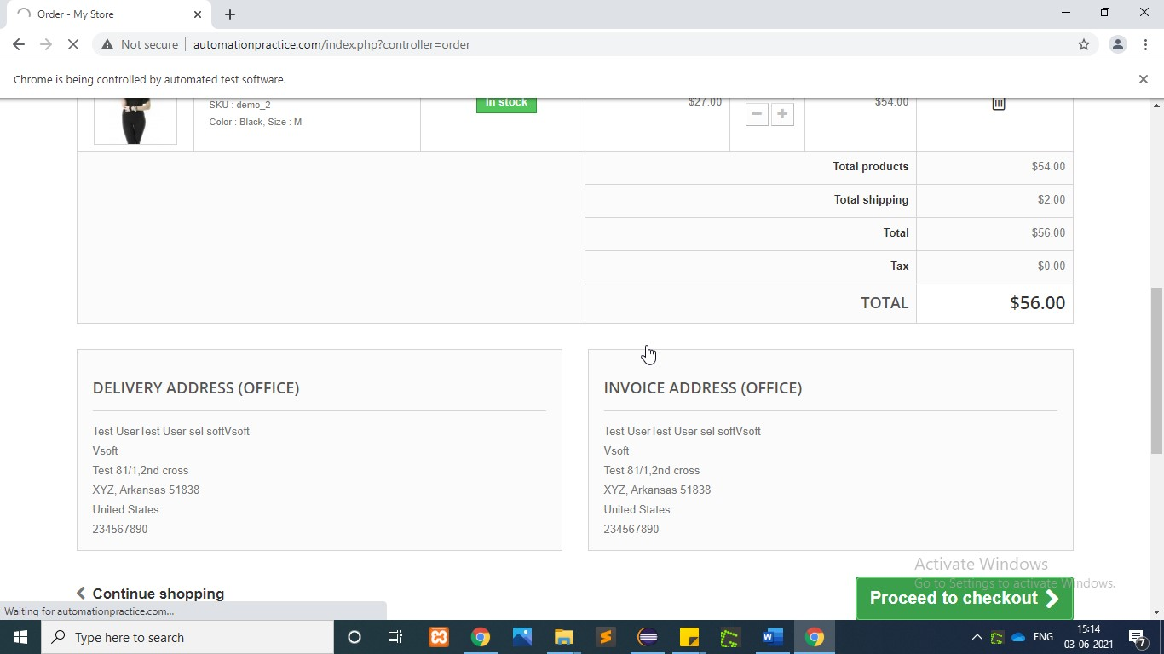

w.findElement(By.*xpath*("/html/body/div[1]/div[2]/div/div[3]/div/p[2]/a[1]/s pan")).click();

w.findElement(By.*xpath*("/html/body/div[1]/div[2]/div/div[3]/div/form/p/butt on/span" )).click();

**T**

**C40**

**To test the functionality**

**of “Confirmed Address”**

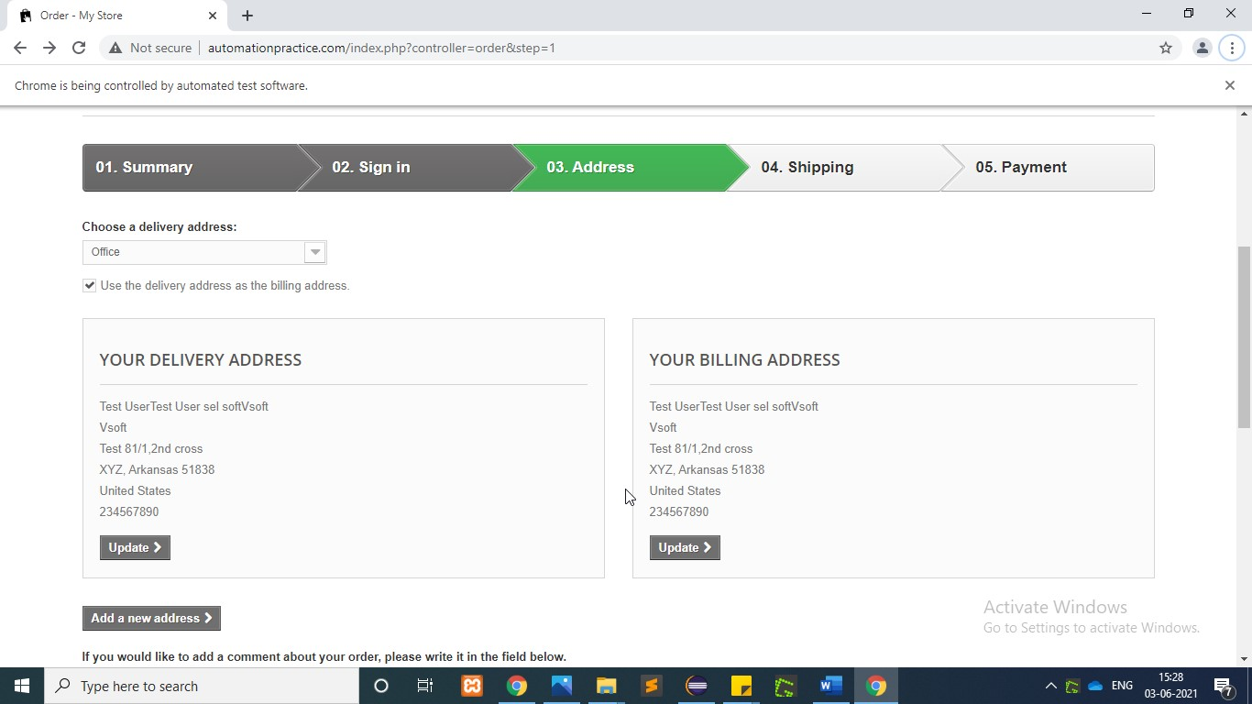

|  |
| --- |
| w.findElement(By.*xpath*("//*[@id=\"cgv\"]")).click();  w.findElement(By.*xpath*("/html/body/div[1]/div[2]/div/div[3]/div/div/form/p/ button/span" )).click(); |

## TC41 To test the functionality of “Shipping”

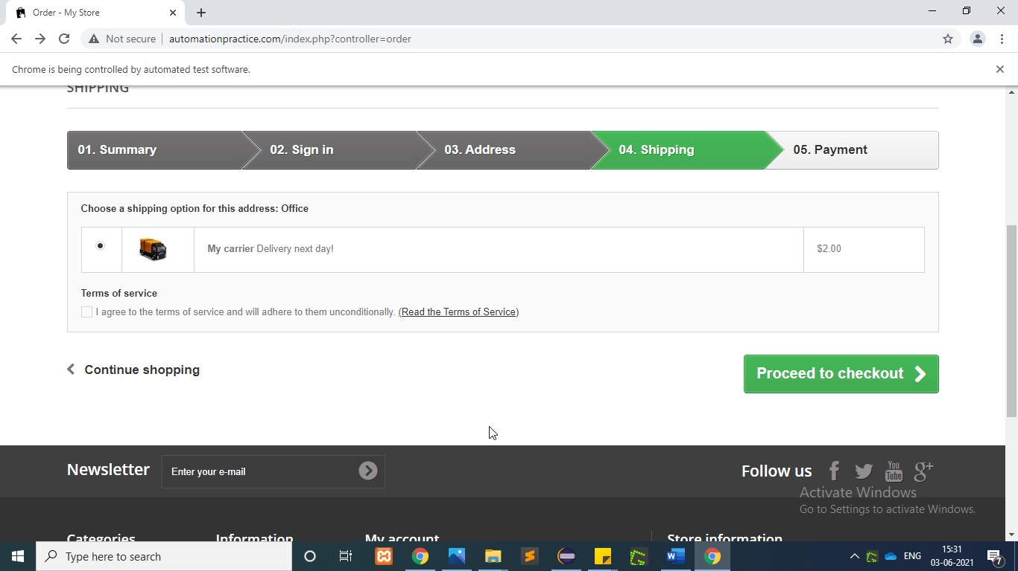

|  |  |  |  |  |
| --- | --- | --- | --- | --- |
| |  |  | | --- | --- | | w.findElement(By.*xpath*("/html/body/div[1]/div[2]/div/div[3]/div/div/div[3]/ | | | div[2]/div/p/a")).click(); |  | |

**T**

**C42**

**To test the functionality**

**of “**

**Payment**

**”**

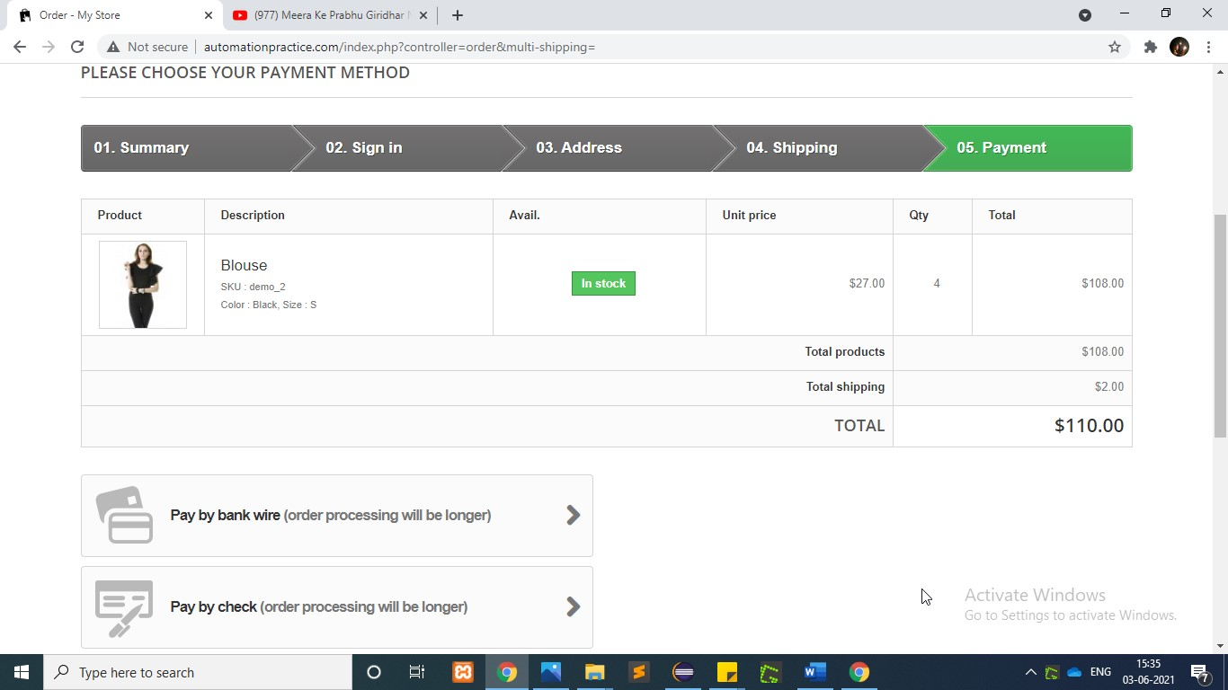

|  |  |  |  |  |
| --- | --- | --- | --- | --- |
| |  |  | | --- | --- | | .findElement(By.*xpath*("/html/body/div[1]/div[2]/div/div[3]/div/div/div[3]/ | | | div[2]/div/p/a")).click(); |  |   w |

|  |  |  |  |  |
| --- | --- | --- | --- | --- |
| |  |  | | --- | --- | | w.findElement(By.*xpath*("/html/body/div[1]/div[2]/div/div[3]/div/form/p/butt | | | on/span")).click(); |  | |

**T**

**C43**

**To test the functionality**

**of “Confirm order”**

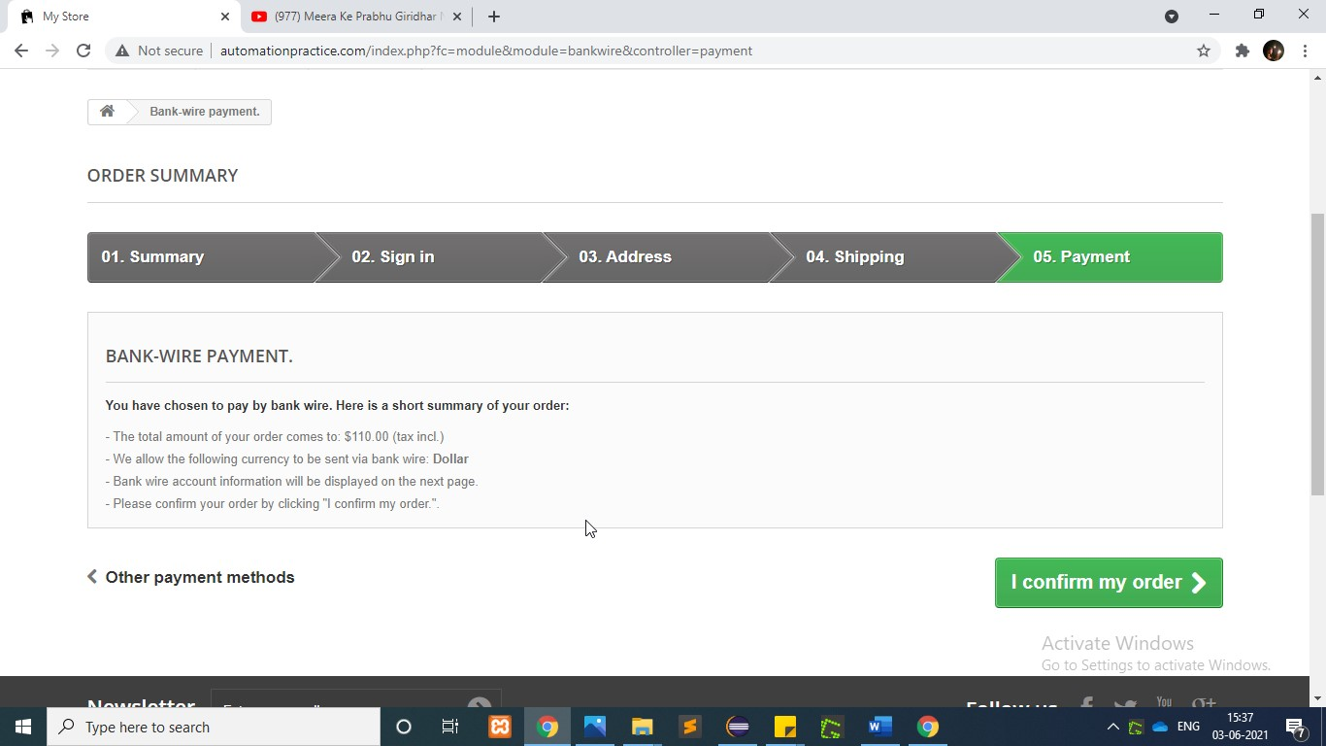

## TC44 To test the functionality of “Dresses Tab”

**To test the functionality**

**of “Confirm order”**

**T**

**C45**

**To test the functionality**

**of “**

**Evening**

**Dresses Tab”**

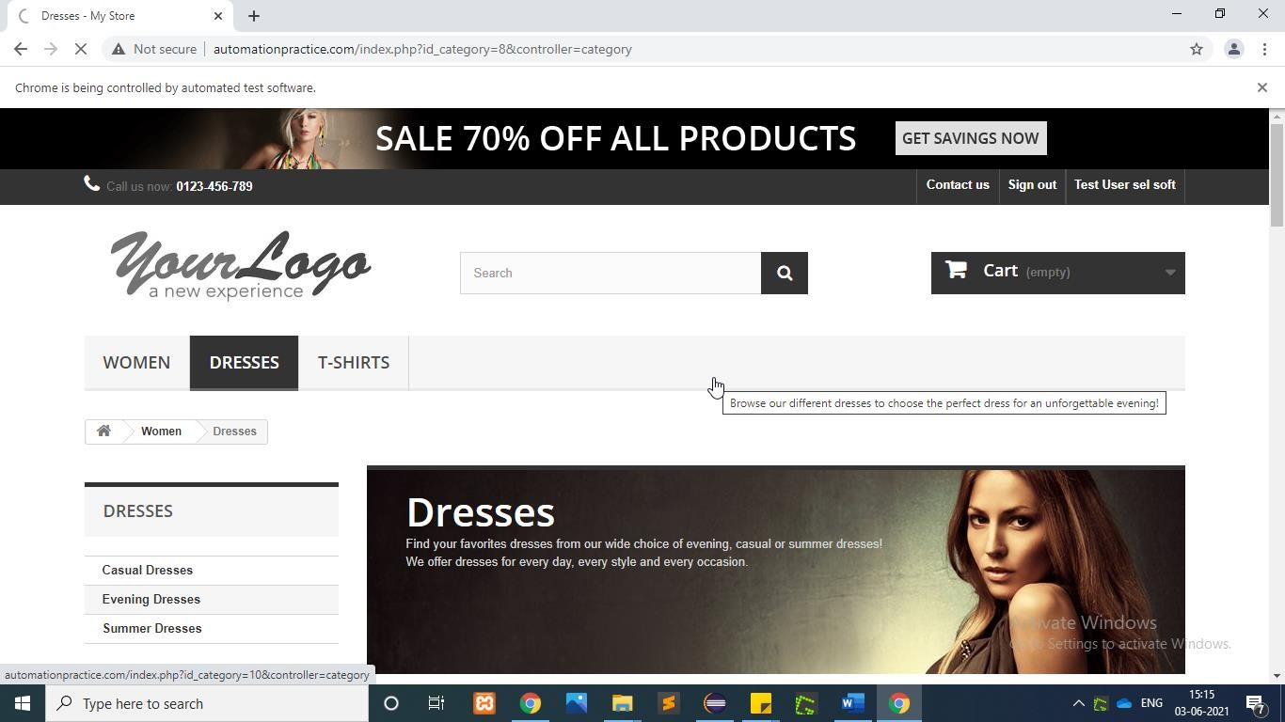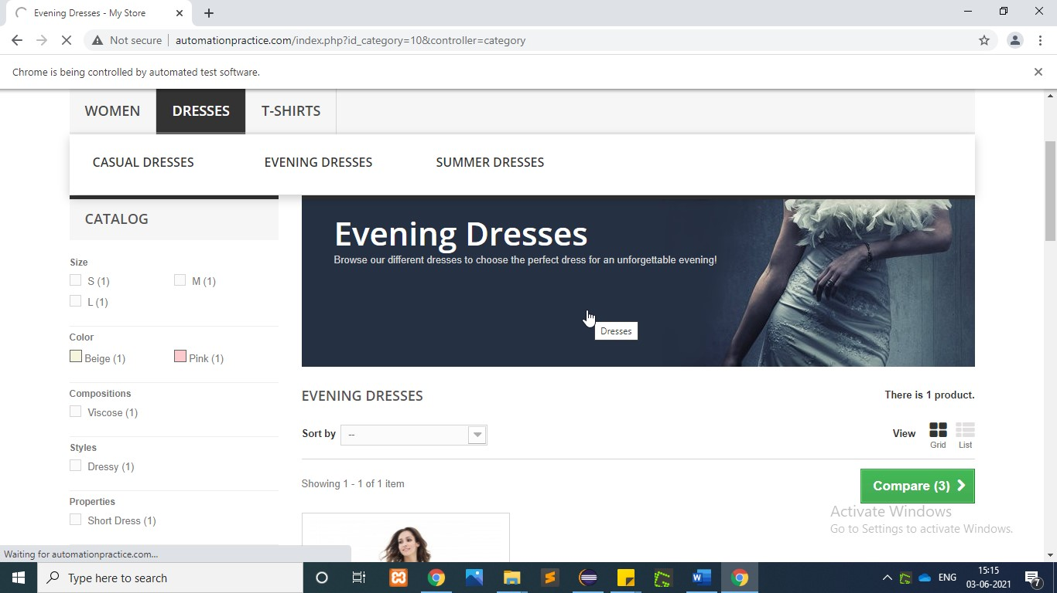

w

.findElement(By.

*xpath*

(

"//header/div[3]/div[1]/div[1]/div[6]/ul[1]/li[2]/a[

1]

"

))

.click();

w.findElement(By.*linkText*("Evening Dresses")).click();

**T**

**C46**

**To test the functionality**

**of “Add To Wish”**

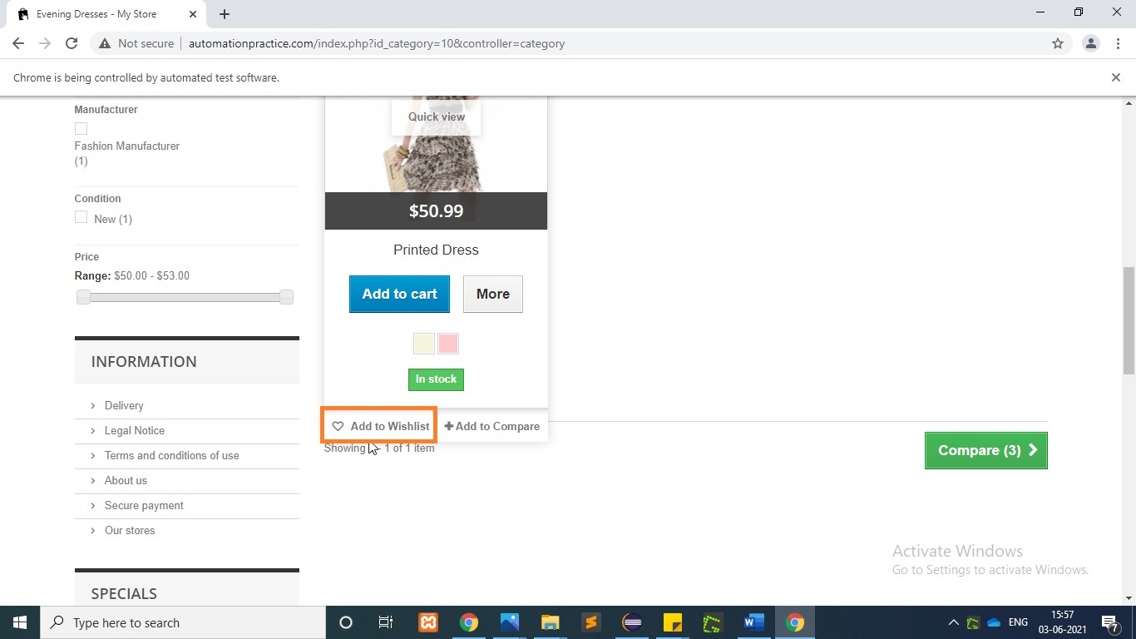

WebElement PrintedDress=w.findElement(By.*xpath*("/html[1]/body[1]/div[1]/

div[2]/div[1]/div[3]/div[2]/ul[1]/li[1]/div[1]/div[1]/div[1]/a[1]/img[1]"));

WebElement AddToWishlist=w.findElement(By.*xpath*("/html[1]/body[1]/div[1]

/div[2]/div[1]/div[3]/div[2]/ul[1]/li[1]/div[1]/div[3]/div[1]/a[1]"));

Actions actions2=**new** Actions(w);

actions2.moveToElement(PrintedDress).moveToElement(AddToWishlist).click().pe

rform();

## TC47 To test the functionality of “Summer Dresses Tab”

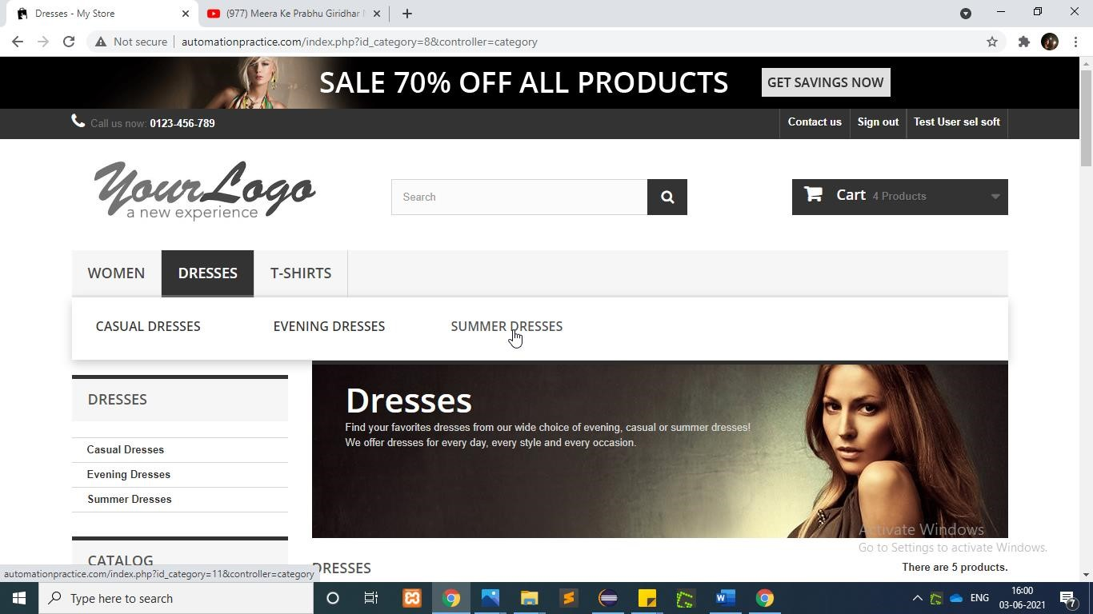

|  |
| --- |
| w.findElement(By.*xpath*("//header/div[3]/div[1]/div[1]/div[6]/ul[1]/li[2]/a[1  ]")).click();  w.findElement(By.*linkText*("Summer Dresses")).click(); |

## TC48 To test the functionality of “Add to Compare Dress1”

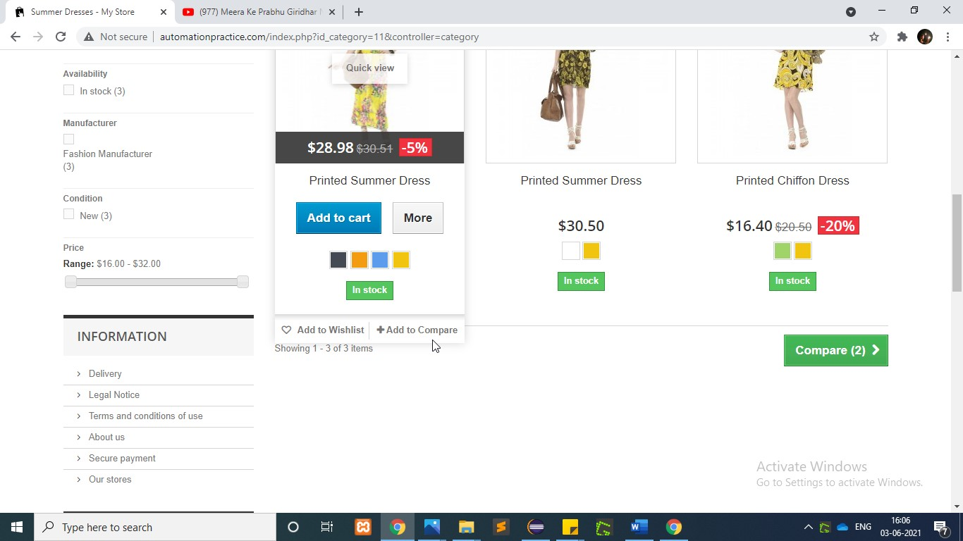

WebElement CompareDress1=w.findElement(By.*xpath*("/html[1]/

body[1]/div[1]/div[2]/div[1]/div[3]/div[2]/ul[1]/li[1]/div[1]/div[1]/div[1]/ a[1]/img[1]"));

WebElement

AddToCompare=w.findElement(By.*xpath*("/html[1]/body[1]

/div[1]/div[2]/div[1]/div[3]/div[2]/ul[1]/li[1]/div[1]/div[3]/div[2]/a[1]"))

;

Actions actions3=**new** Actions(w);

actions3 .moveToElement(CompareDress1).moveToElement(AddToCompare).click().pe

rform();

## TC49 To test the functionality of “Add to Compare Dress2”

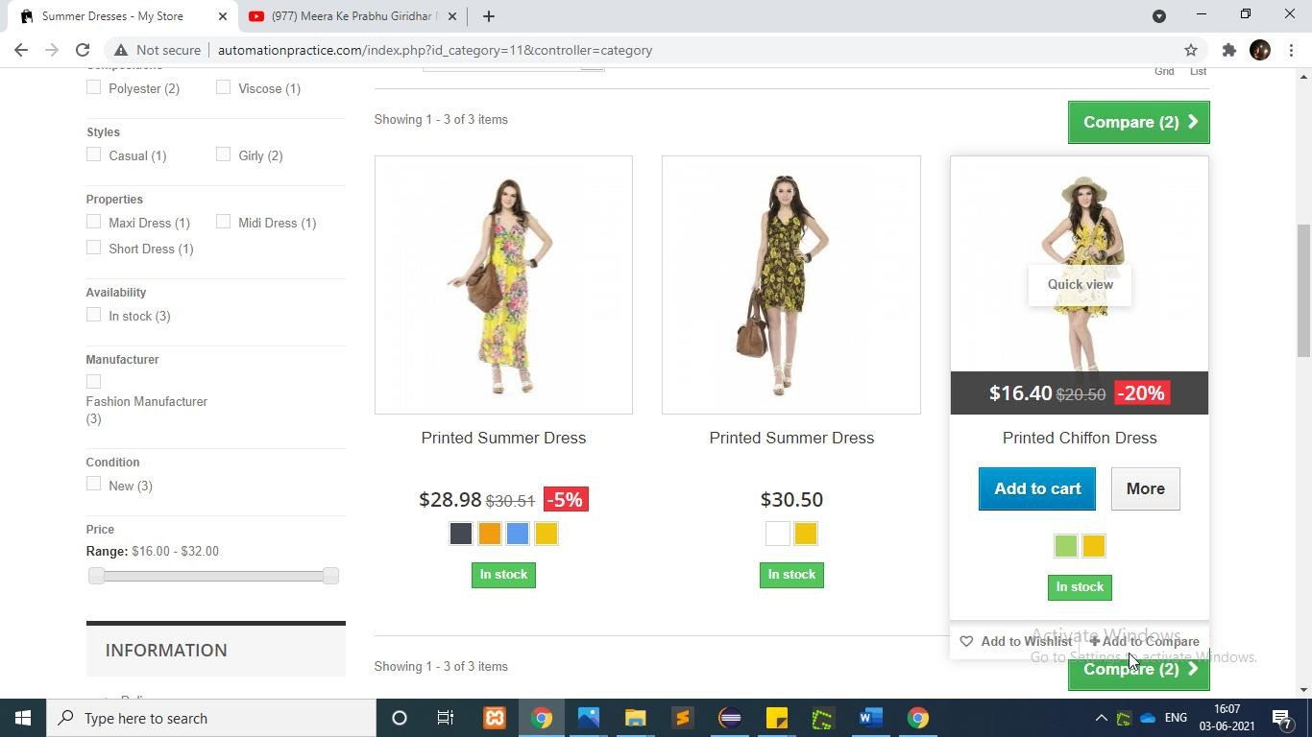

WebElement

CompareDress2=w.findElement(By.*xpath*("/html[1]/body[1]/div[1]/div[2]/div[1]/ div[3]/div[2]/ul[1]/li[3]/div[1]/div[2]"));

WebElement

AddToCompare1=w.findElement(By.*xpath*("/html[1]/body[1]/div[1]/div[2]/div[1]/ div[3]/div[2]/ul[1]/li[3]/div[1]/div[3]/div[2]/a[1]"));

Actions actions4=**new** Actions(w);

actions4.moveToElement(CompareDress2).moveToElement(AddToCompare1).click().p

erform();

## TC50 To test the functionality of “Compare Button”

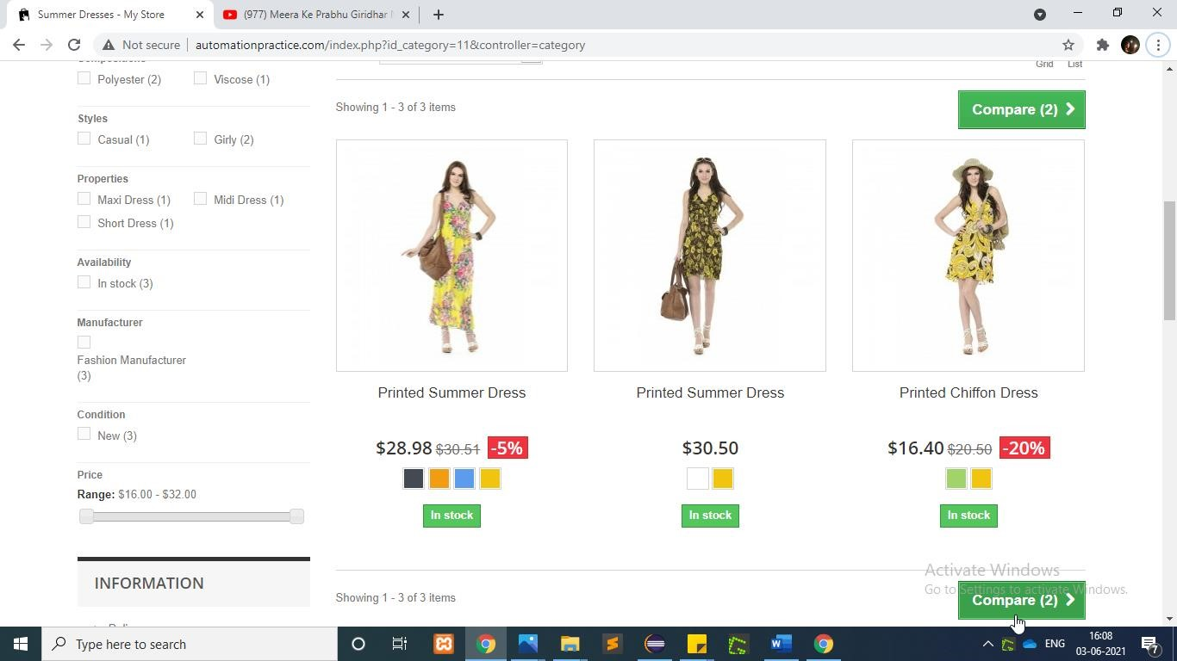

|  |
| --- |
| w.findElement(By.*xpath*("/html[1]/body[1]/div[1]/div[2]/div[1]/div[3]/div[2]/  div[2]/div[2]/form[1]")).click();      w.findElement(By.*xpath*("/html[1]/body[1]/div[1]/div[2]/div[1]/div[3]/div[1]/  ul[1]/li[1]/a[1]/span[1]")).click(); |

**T**

**C51**

**To test the functionality**

**of “**

**MenuBar**

**”**

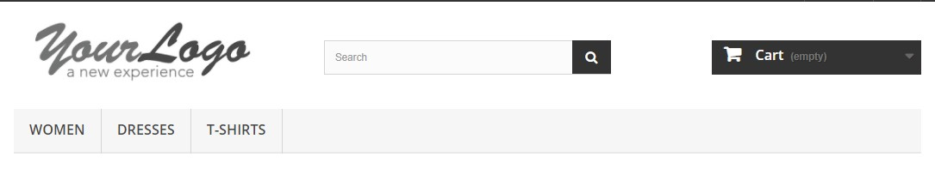

//click on woman

w.findElement(By.*linkText*("WOMEN")).click();

w.navigate().back();

//click on dresses

w.findElement(By.*xpath*("/html[1]/body[1]/div[1]/div[1]/header[1]/div[3] /div[1]/div[1]/div[6]/ul[1]/li[2]/a[1]")).click();

w.navigate().back();

//click on t-shirt

w.findElement(By.*xpath*("/html[1]/body[1]/div[1]/div[1]/header[1]/div[3] /div[1]/div[1]/div[6]/ul[1]/li[3]/a[1]")).click();

w.navigate().back();

**T**

**C52**

**To test the functionality**

**of “**

**Search Bar**

**”**



|  |
| --- |
| //serach bar String  ProductName=w.findElement(By.*xpath*("/html[1]/body[1]/div[1]/div[2]/div[1]/di v[2]/div[1]/div[1]/ul[1]/li[3]/div[1]/div[2]/h5[1]/a[1]")).getText(); System.***out***.println(ProductName);    w.findElement(By.*id*("search_query_top")).sendKeys(ProductName);  w.findElement(By.*name*("submit_search")).click();  w.navigate().back(); |

**T**

**C53**

**To test the functionality**

**of “**

**Best Sellers**

**”**

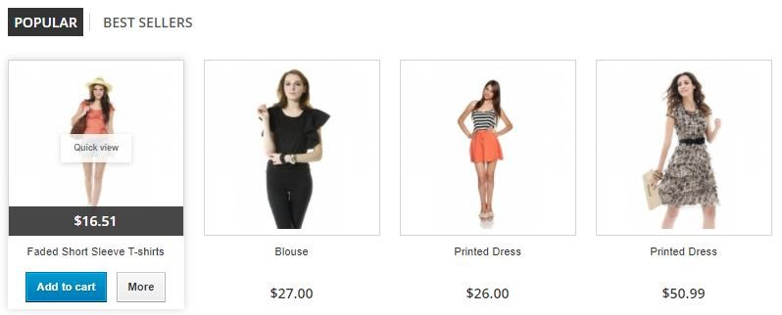

//To check the Best Seller tab

w.findElement(By.*xpath*("/html[1]/body[1]/div[1]/div[2]/div[1]/div[2]/di v[1]/ul[1]/li[2]/a[1]")).click();

## TC54 To test the functionality of “Top Trends”



//To check The Top trends

w.findElement(By.*xpath*("/html[1]/body[1]/div[1]/div[2]/div[1]/div[2]/di

v[1]/div[2]/div[1]/ul[1]/li[1]/a[1]/img[1]")).click();

w.navigate().back();

**T**

**C55**

**To test the functionality**

**of “**

**Newsletter**

**”**

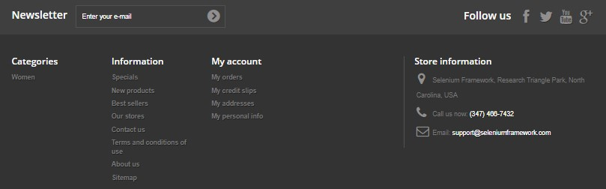

//To check the newslatter tab

w.findElement(By.*id*("newsletter-input")).sendKeys("mystore@test.com");

w.findElement(By.*name*("submitNewsletter")).click();

w.navigate().back();

## TC56 To test the functionality of “Best sellers”



//to check best Seller

w.findElement(By.*xpath*("/html[1]/body[1]/div[1]/div[3]/footer[1]/div[1] /section[3]/ul[1]/li[2]/a[1]")).click();

**T**

**C57**

**To test the functionality**

**of “My account”**



|  |
| --- |
| //to check My Account section    w.findElement(By.*xpath*("/html[1]/body[1]/div[1]/div[3]/footer[1]/  div[1]/section[5]/div[1]/ul[1]/li[1]/a[1]")).click();    //Login  w.findElement(By.*id*("email")).sendKeys("vsoft1120@test.com");  w.findElement(By.*id*("passwd")).sendKeys("vosft1212");  w.findElement(By.*id*("SubmitLogin")).click(); |

## TC58 To test the functionality of “My account page”

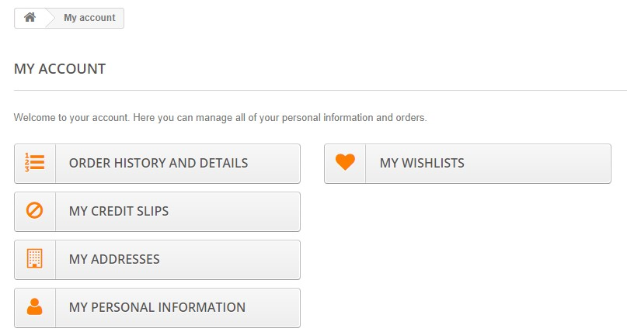

//click to check my wishlist

w.findElement(By.*xpath*("/html[1]/body[1]/div[1]/div[2]/div[1]/div[3]/div[1]/

div[1]/div[2]/ul[1]/li[1]/a[1]/span[1]")).click();

**T**

**C59**

**To test the functionality**

**of “My wishlist”**

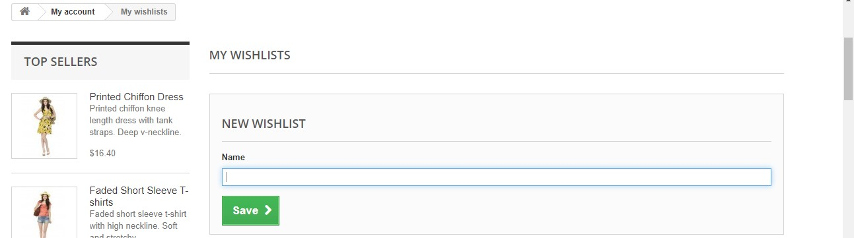

|  |
| --- |
| //to add item in wish list  w.findElement(By.*id*("name")).sendKeys("Printed Chiffon Dress");  w.findElement(By.*id*("submitWishlist")).click();  w.findElement(By.*xpath*("/html[1]/body[1]/div[1]/div[2]/div[1]/div[3]/div[2]/ div[1]/ul[1]/li[1]/a[1]/span[1]")).click();  //back to home  w.findElement(By.*xpath*("/html[1]/body[1]/div[1]/div[2]/div[1]/div[3]/div[1]/  ul[1]/li[1]/a[1]/span[1]")).click(); |